Software Design Specification

(SDS)

Sports Complex Management System

Version 1.0

Prepared by

Syeda Sana Zehra Zaidi

Hamna Rauf

Hamna Naveed

BESE 11A

NUST-SEECS

Contents

1. Introduction 2

1.1 System Purpose 2

1.2 System Scope 2

1.3 Definitions, Acronyms, and Abbreviations 2

2. System Overview 2

3. Analysis Model 3

3.1 Interface Objects 3

3.1.2 Acquaintance Association interface objects 4

3.1.2.1 Member Interface 4

3.1.2.1.1 Initial Interface 4

3.1.2.1.2 Register Member Interface 4

3.1.2.1.3 Register Trainee Interface 5

3.1.2.1.4 Register Guest Interface 5

3.1.2.1.5 Remove Member Interface 6

3.1.2.1.6 View All Members Interface 6

3.1.3 Containership 7

3.2 Sub System Diagram 8

3.3 Control Objects 10

4. System Architecture design 14

5. Design Model 14

4.1 Use case diagram 14

4.2 Class diagram 17

4.3 Sequence Diagrams 18

4.3 Communication Diagrams 28

4.4 Activity Diagrams 33

4.5 State machine diagram 38

4.6 Deployment Diagram 41

4.7 Component Diagram 42

4.8 Package Diagram 45

# Introduction

## System Purpose

This document is the next step to Software Requirements Specification (SRS). The purpose of this document is to describe the detail architecture and design specifications for the project entitled “SPORT COMPLEX MANAGEMENT SYSTEM” showing the structure of software system in order to satisfy the requirements. The objective is to make a system that can manage the records, data and servicing activity of different sports, players, coach, management all at a time through a single platform.

## System Scope

This project aims to shift the management of Sports Complex from paper-based to software-based implementation. This will help to optimize the tedious and cumbersome file work with the help of a user-friendly interface. This will ensure authorized service provisioning to every user in every department in the Sport Complex will have their own terminal with system security checks and constraints ensured. This project will be a two-tier implementation and will not require internet connection for its operation

## Definitions, Acronyms, and Abbreviations

|  |  |  |  |  |  |  |  |  |  |  |  |
| --- | --- | --- | --- | --- | --- | --- | --- | --- | --- | --- | --- |
| |  |  | | --- | --- | | **Words** | **Explanation** | | SQL | Structured Query Language | | DBMS | Database Management System | | Combo Box | Drop down list | | Array List | A re-sizable array | | |
|  | |
|  | |
|  |  | |

# System Overview

The final product is implemented as a desktop application with a user-friendly interface and MySQL as DBMS. The major components reside with the departments and multiple users that are Registration, Finance, Manager, Inventory, Attendance, Coach and Emergency.

# Analysis Model



## Interface Objects

Below are the interface objects used for Sports Complex Management System:

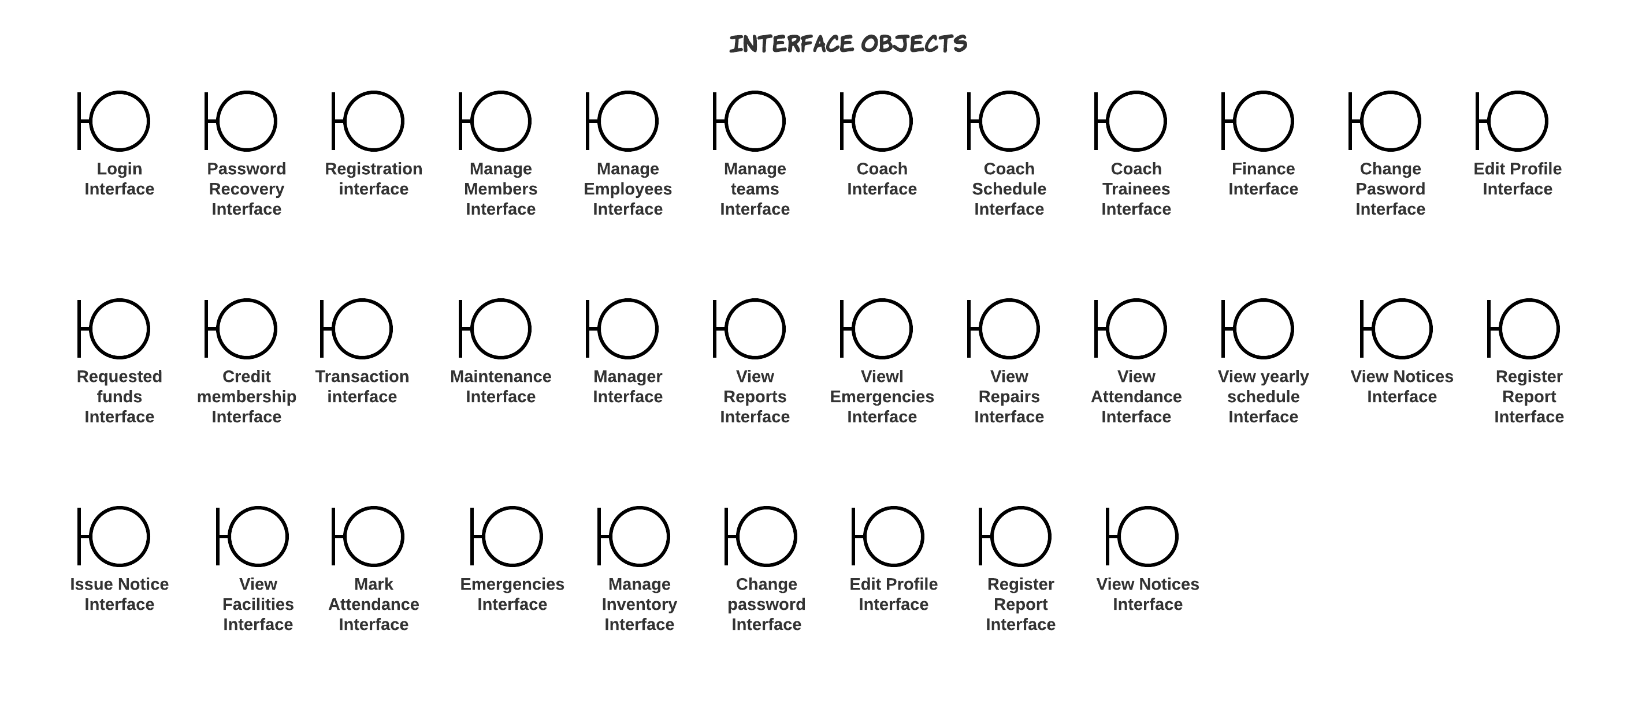

* + 1. **Acquaintance Association interface objects**
       1. **Manage Members:** 
          1. **Initial Interface**

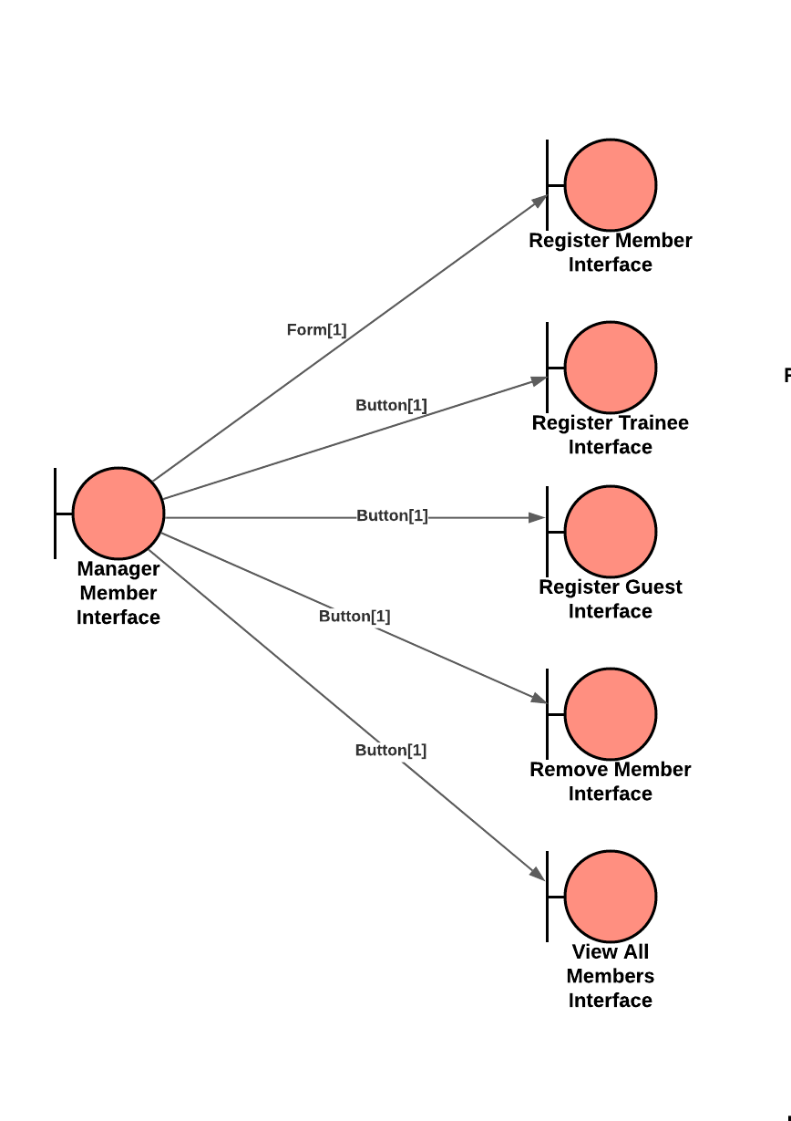

# Register Member Interface

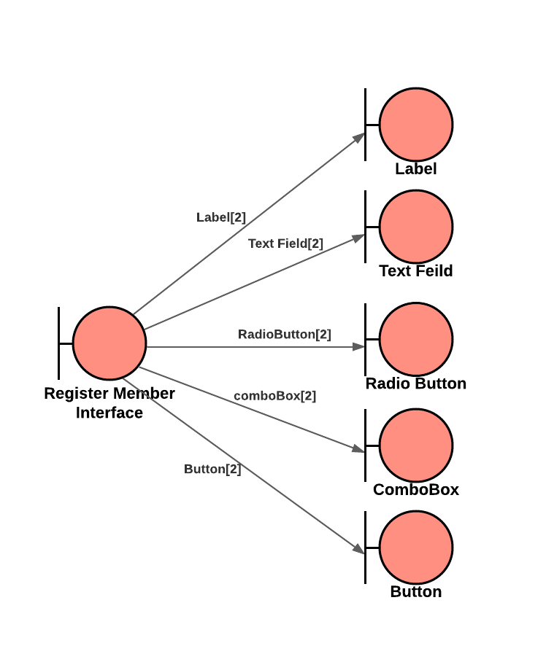

# Register Trainee Interface

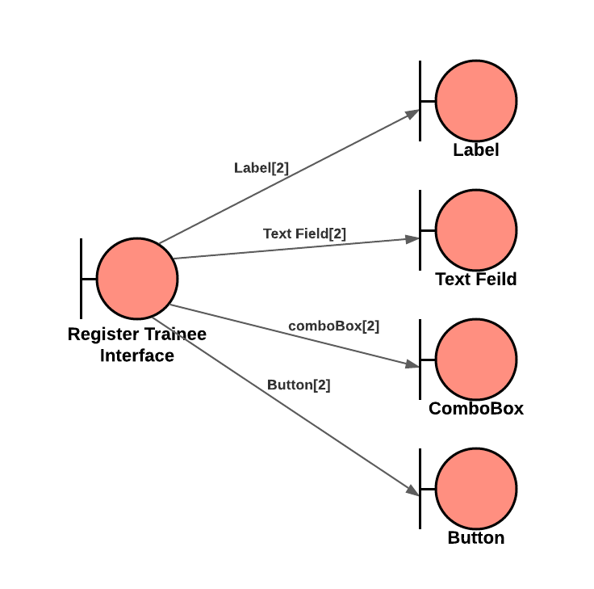

# Register Guest Interface

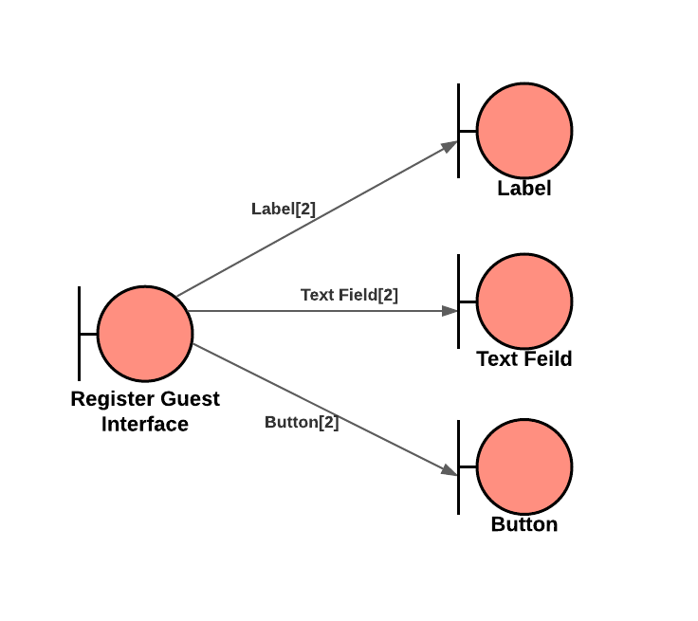

* + - * 1. **Remove Member Interface**

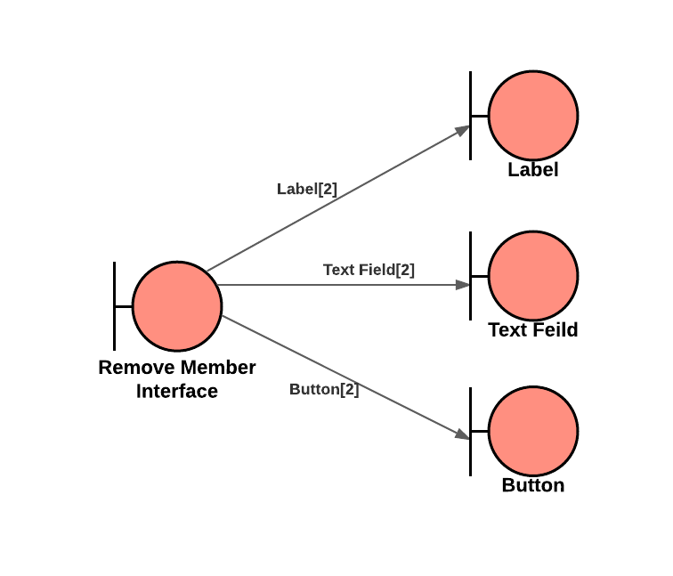

* + - * 1. **View All Members**

# 

### Containership

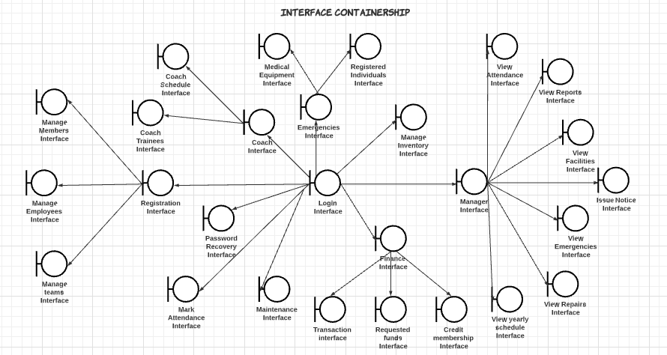

## Sub System Diagram

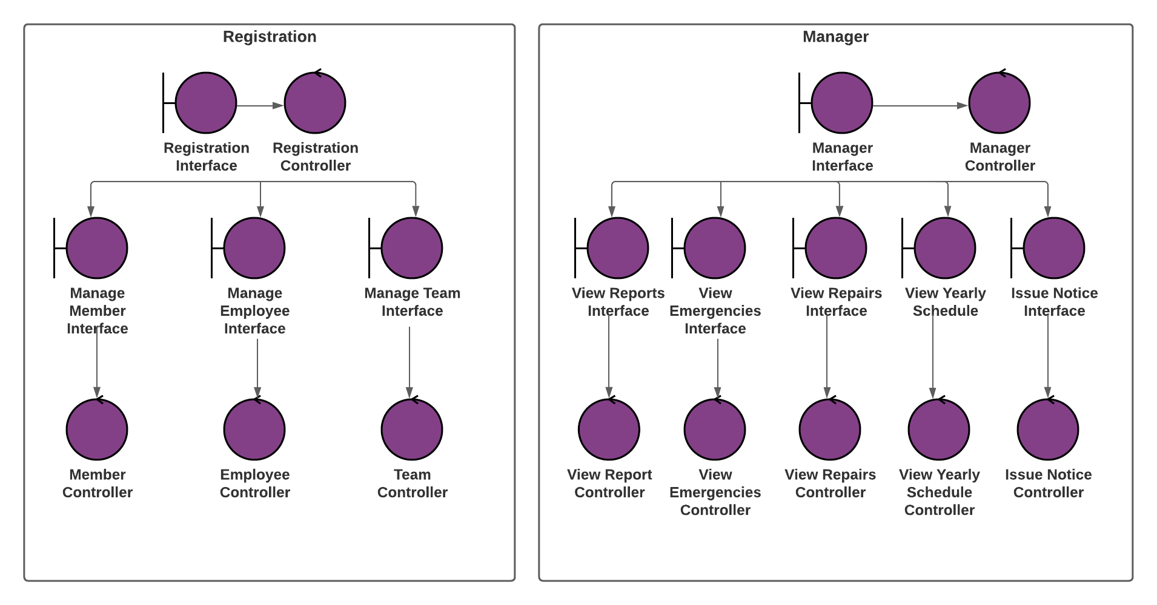

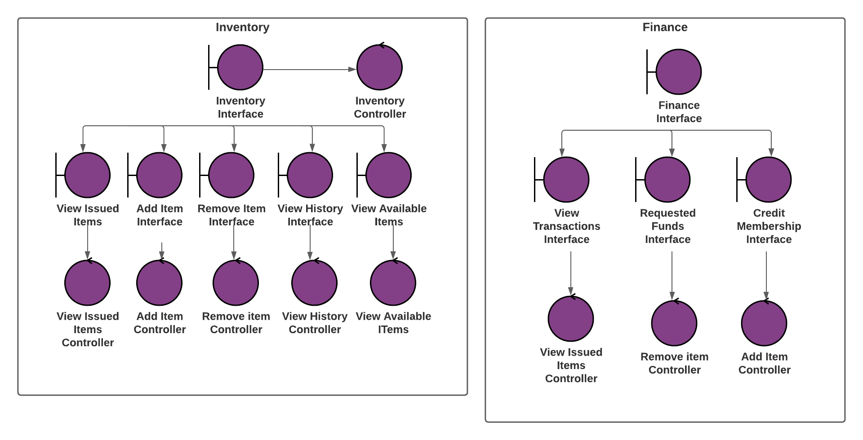

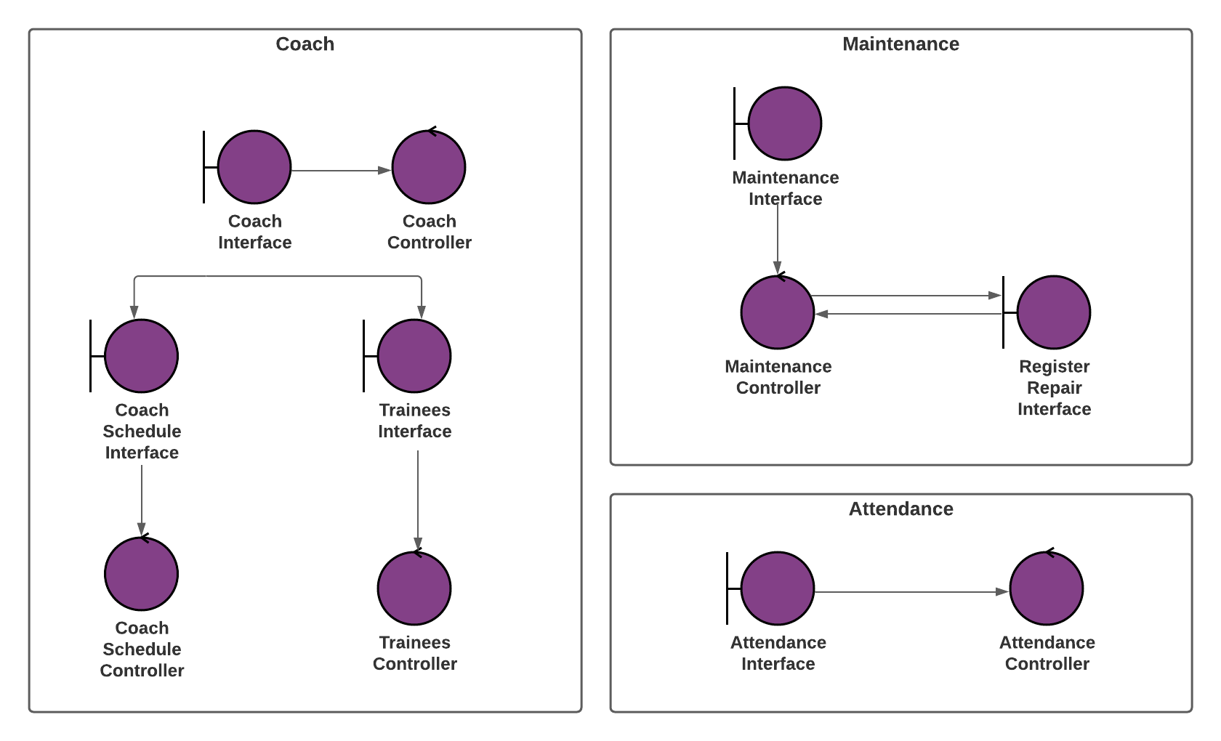

## Control Objects

Control objects are responsible for computation or processing tasks. Following are the main control objects in the proposed framework.

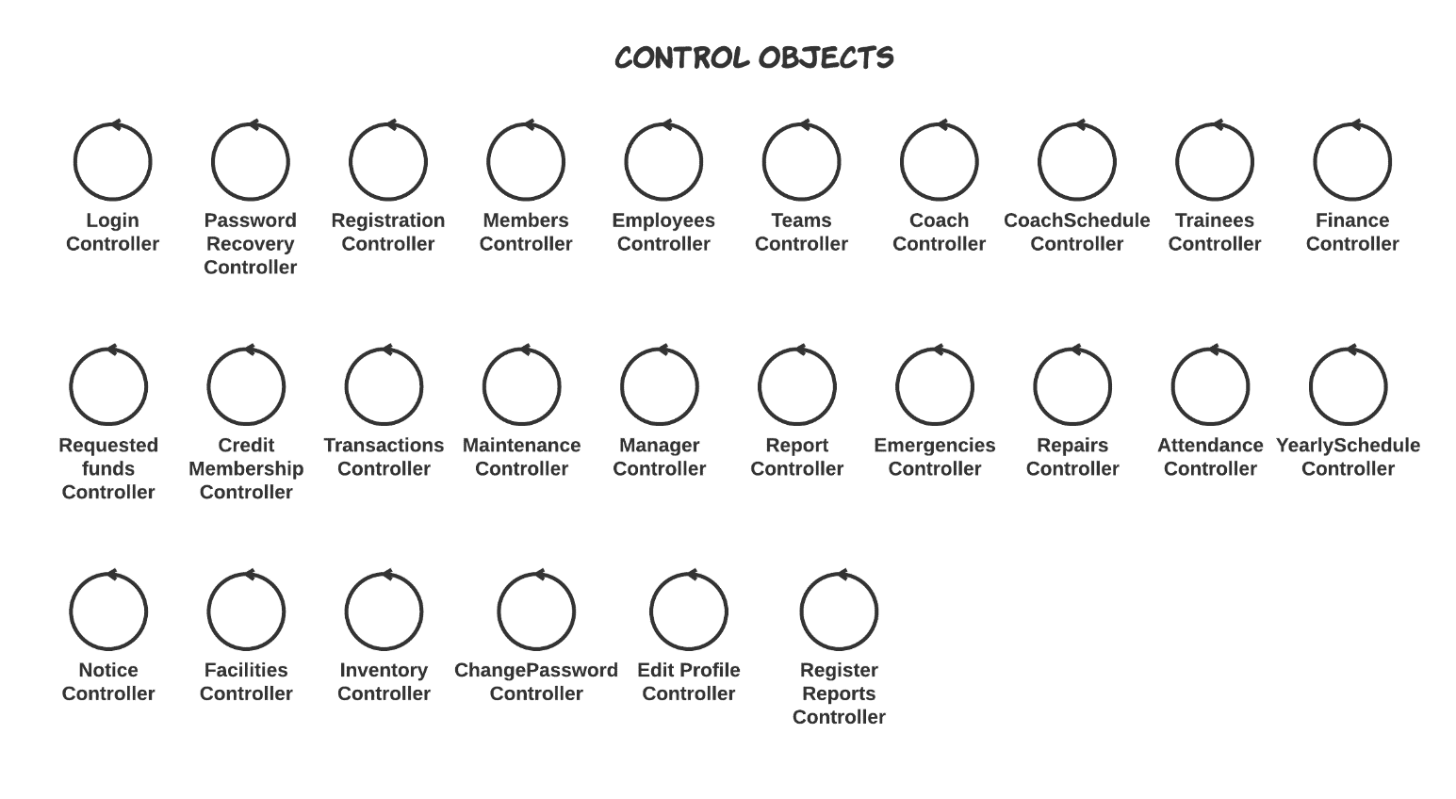

**Description of Control Objects**

1. **Login Controller:**

This control object is responsible for the login of user.

1. **Password Recovery Controller:**

This control object is used to manage password recovery for users.

1. **Registration Controller:**

This control object is used to manage functionality of Registration department. It is used to navigate between Manage Member Interface, Manage Employees Interface and Manage Teams Interface.

1. **Member Controller:**

This control object is used to manage Members. It handles all the Register Members, Remove Members and View All Members operations as per user request.

1. **Employee Controller:**

This control object is used to manage Employees. It handles all the Register Employee, Remove Employee and View All Employees operations as per user request.

1. **Teams Controller:**

This control object is used to manage team. It handles all the Register team, Remove team and View All team operations as per user request.

1. **Coach Controller:**

This is used to navigate between coach’s schedule and coach’s trainees.

1. **Coach Schedule Controller:**

This control object is used to display coach’s schedule.

1. **Trainees Controller:**

This control object is used to display coach’s trainees.

1. **Finance Controller:**

This Controller is used to navigate between the functionality provided to the finance department.

1. **Requested Funds Controller:**

This control object is used to manage requested funds. It handles funds allocation and rejection.

1. **Credit Membership Controller:**

This control object is used to credit members. It displays the membership form to the user.

1. **Transactions Controller:**

This control object is used to display all transactions taken place along with their details and summary.

1. **Maintenance Controller:**

This control object is used to mark the level of completeness of certain activity of maintenance and register repairs if any.

1. **Manager Controller:**

This Control object is used to navigate between the functionality provided to manager.

1. **Report Controller:**

This control object displays all reports to manager interface. It handles addressing or removing reports as well.

1. **Emergencies Controller:**

This control object displays all emergencies to the manager interface.

1. **Repairs Controller:**

This control object displays all repairs, theirs details to the manager.

1. **Attendance Controller:**

This control object displays the attendance of employees to the manager.

1. **Yearly Schedule Controller:**

This control object displays yearly schedule to the manager.

1. **Notice Controller:**

This control is used to issue notice.

1. **Facilities Controller:**

This control displays all facilities in Sports Complex to manager.

1. **Inventory Controller:**

This control object is used add, remove items, display available and history of inventory along with issue an item to member.

1. **Change Password Controller:**

This control object responsible for handling password for the user. It is part of menu and common to all users.

1. **Register Report Controller:**

This control object handles with registration of reports. It is part of menu and common to all users.

1. **Edit Profile Controller:**

This control object is used to edit profile. It is part of menu and common to all users.



# System Architecture design

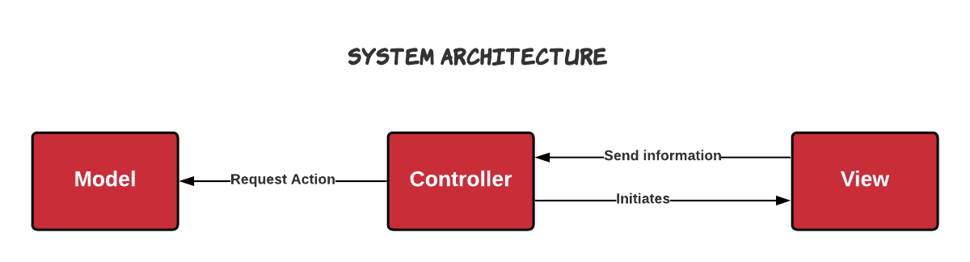

# Design Model

## Use case diagram

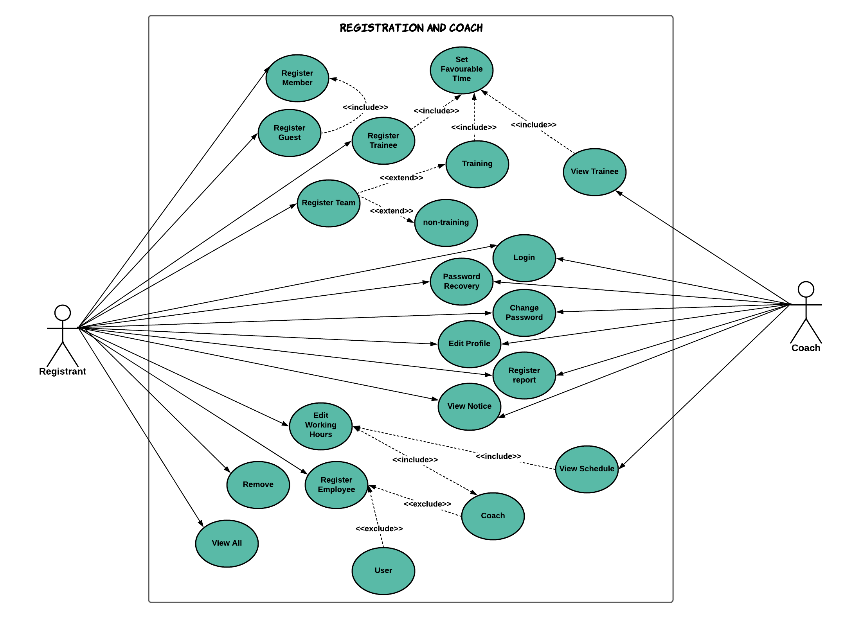

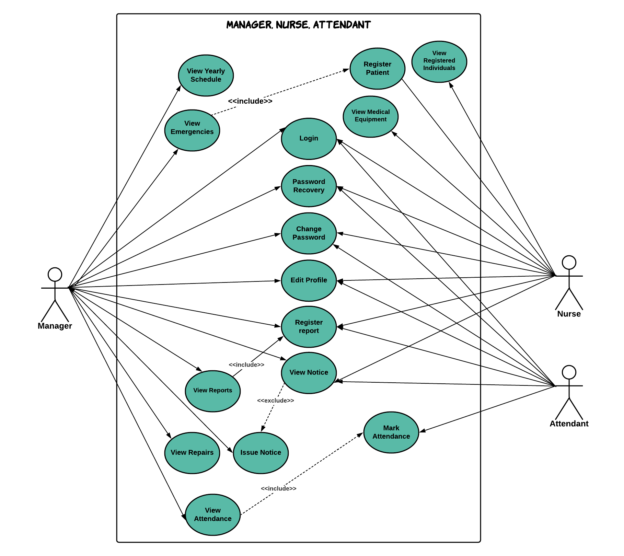

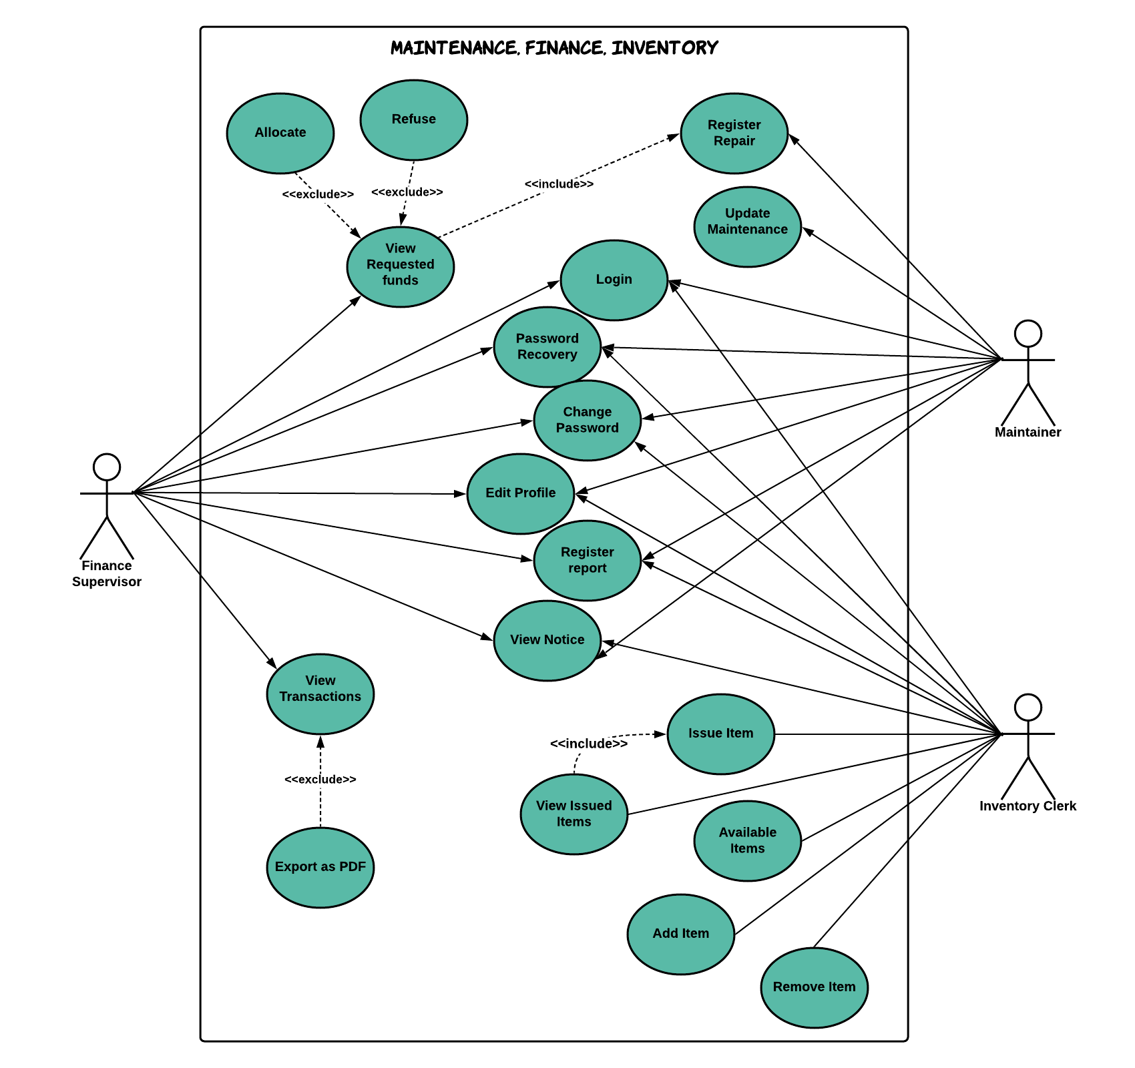

## Class diagram

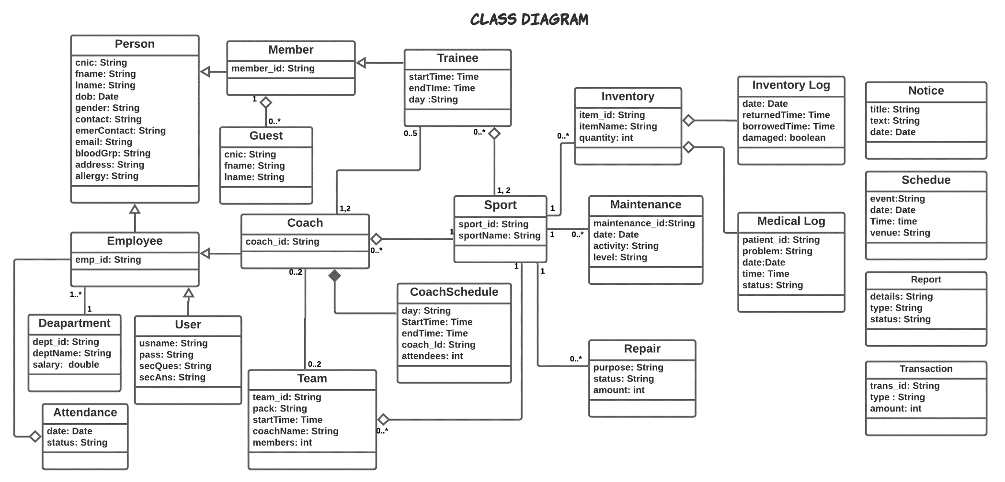

## Sequence Diagrams

* 2. 1. **Login**

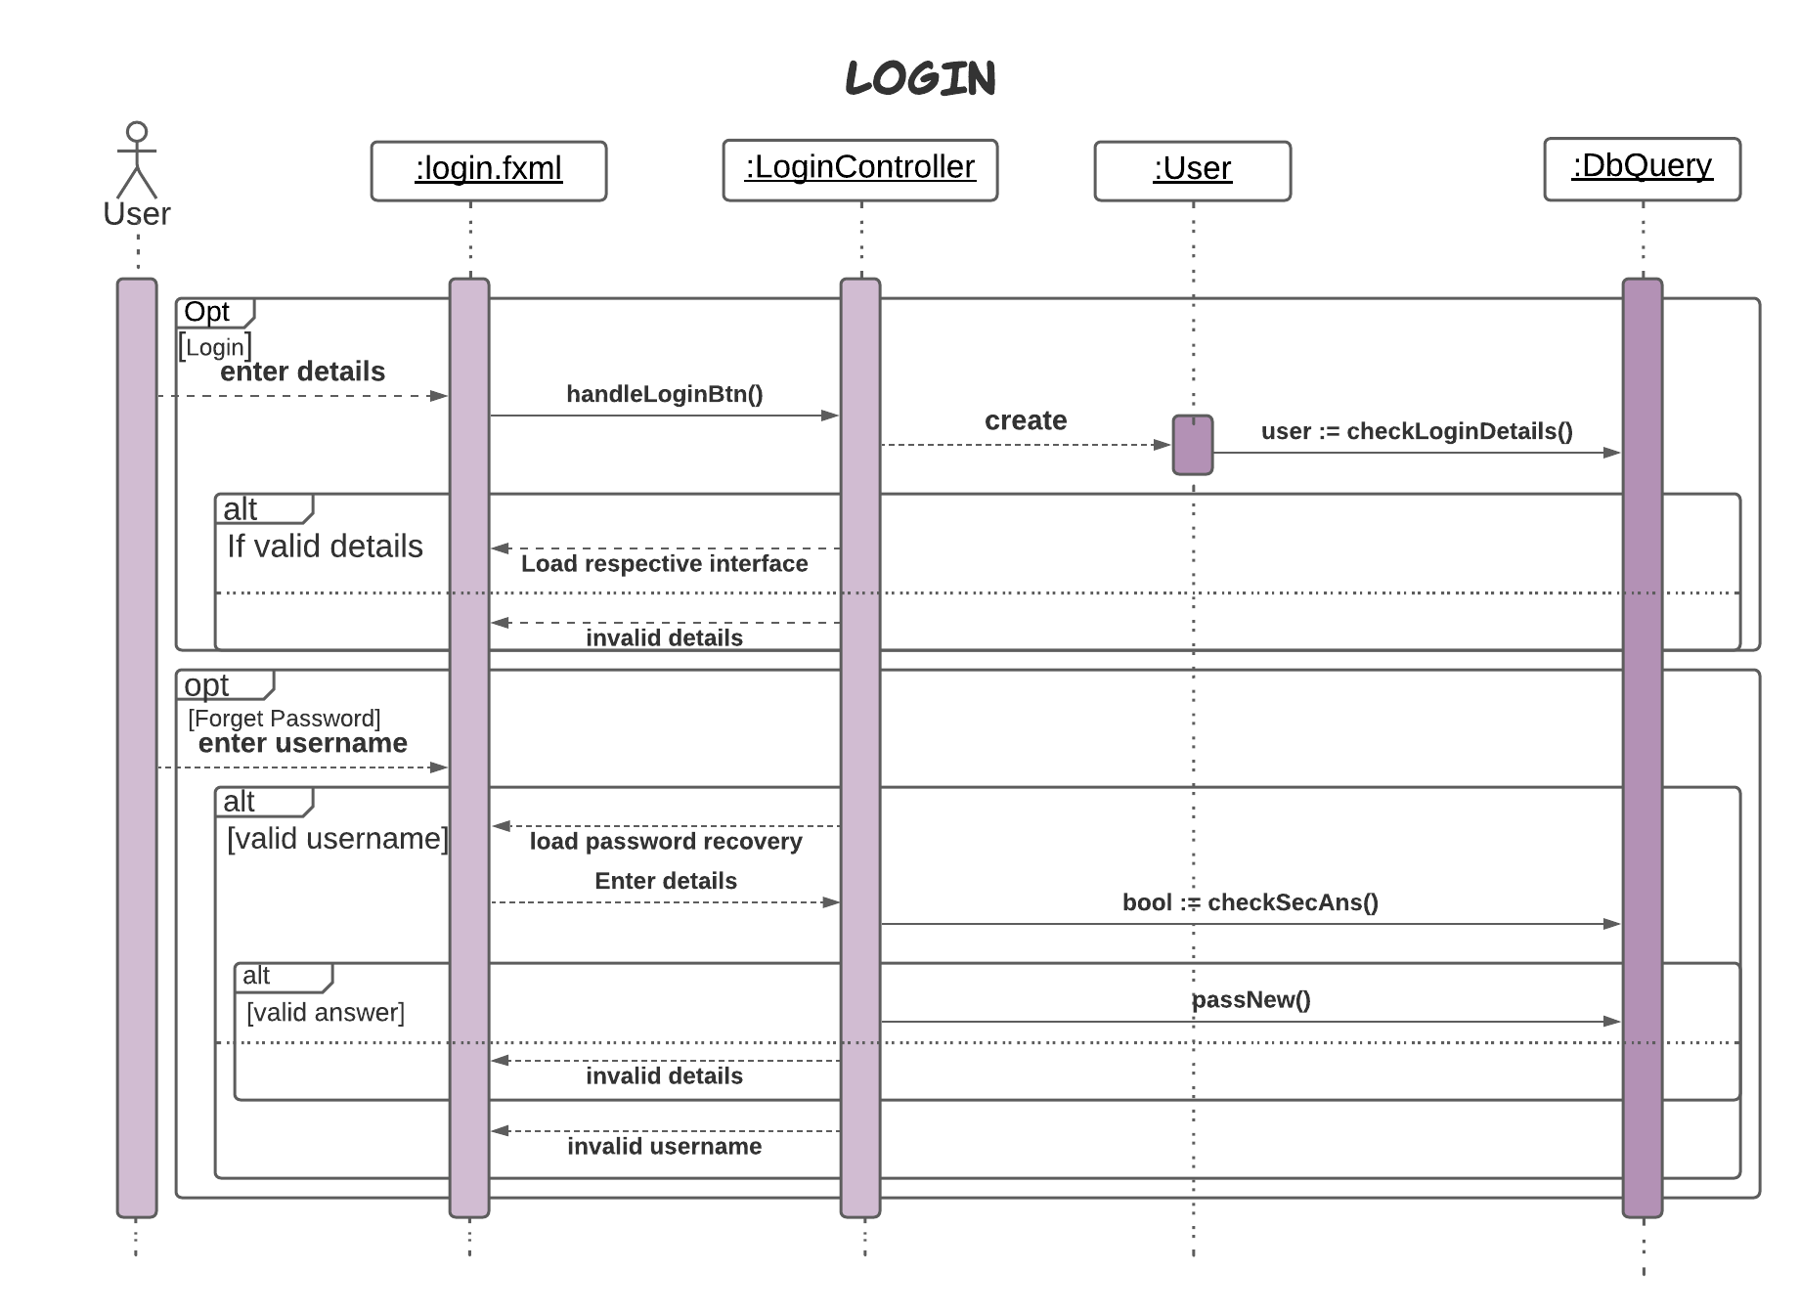

* + 1. **Registration**
       1. **Manage Members**

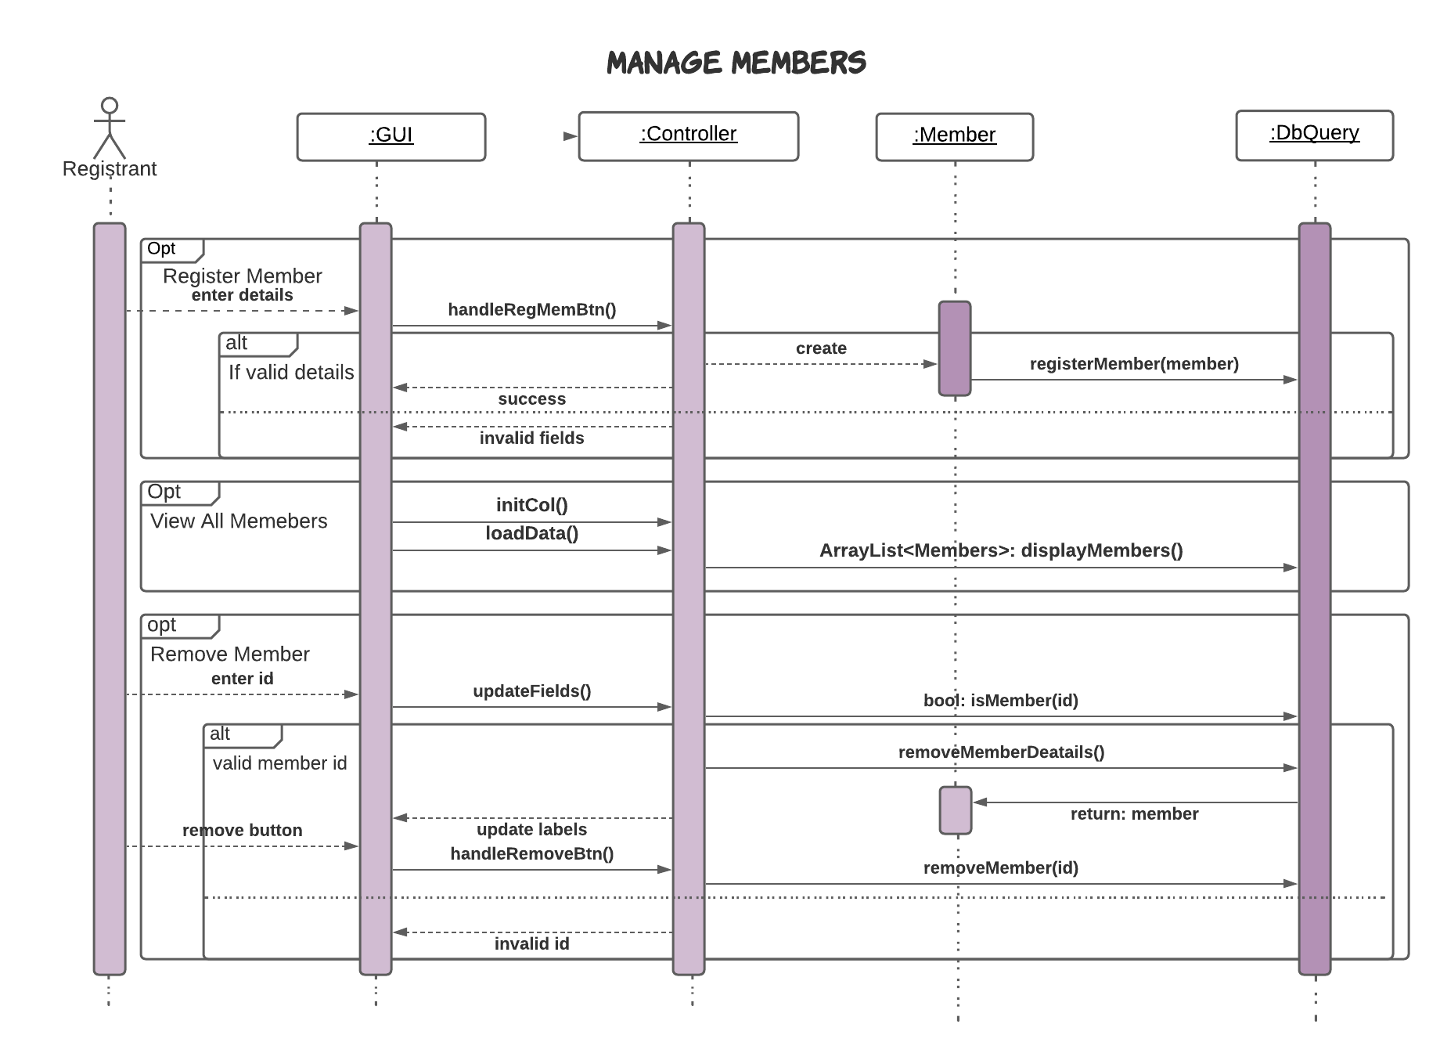

* + - 1. **Manage Employees**

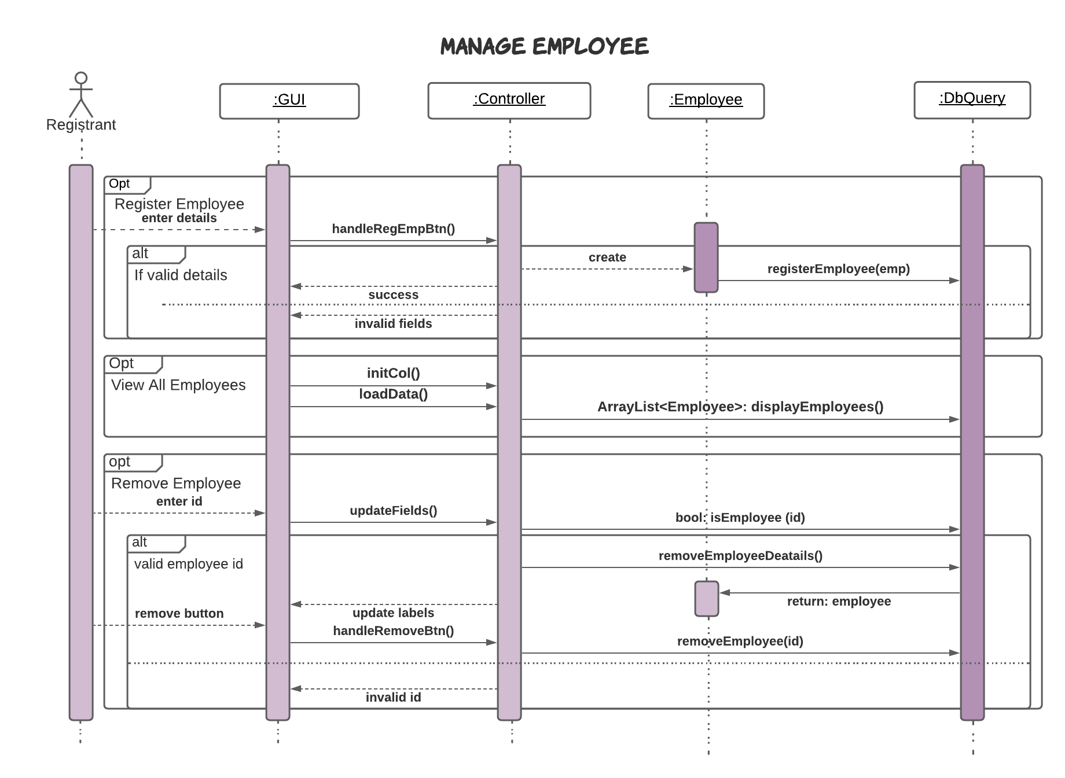

* + - 1. **Manage Teams**

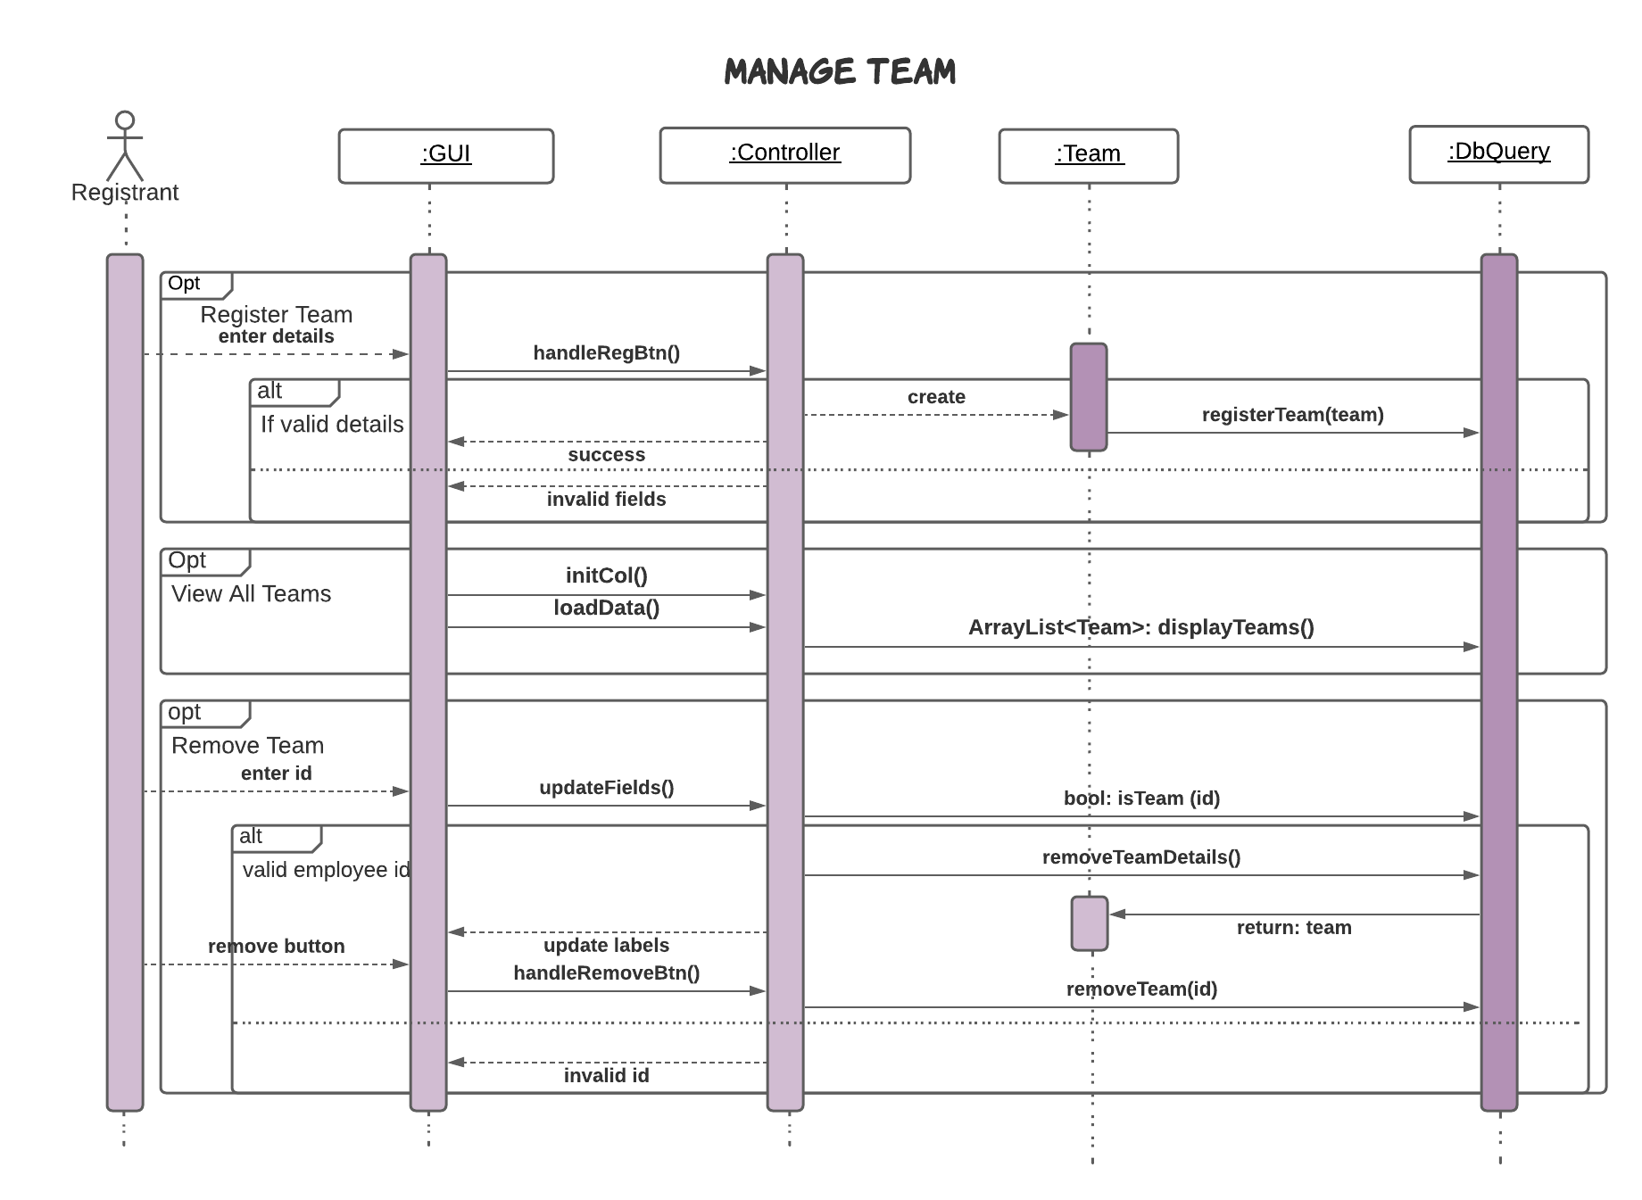

* + 1. **Manager**

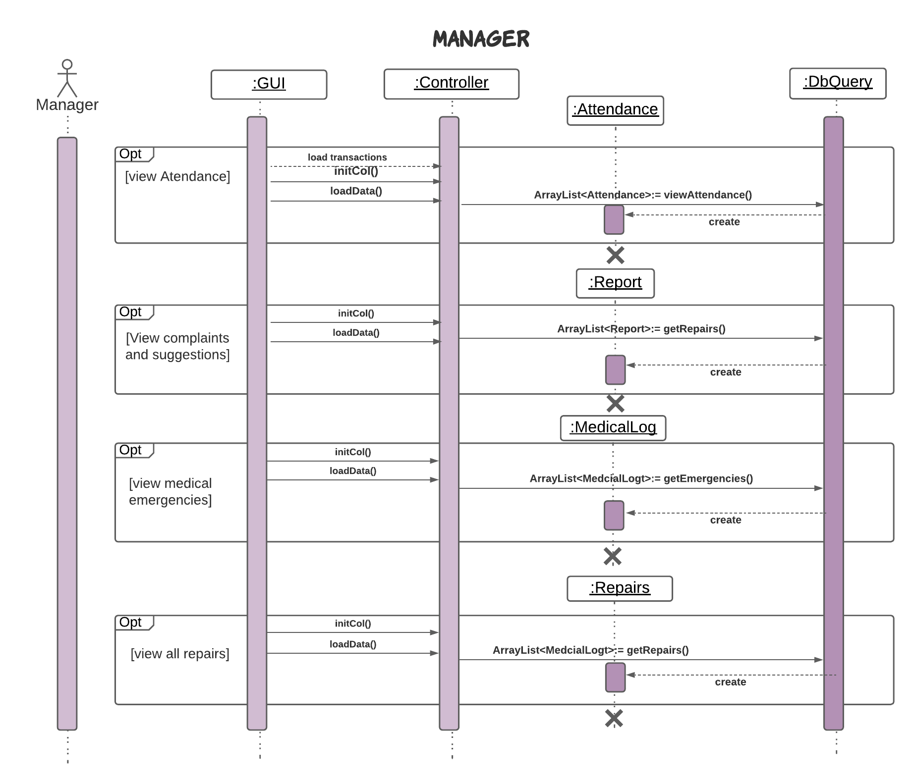

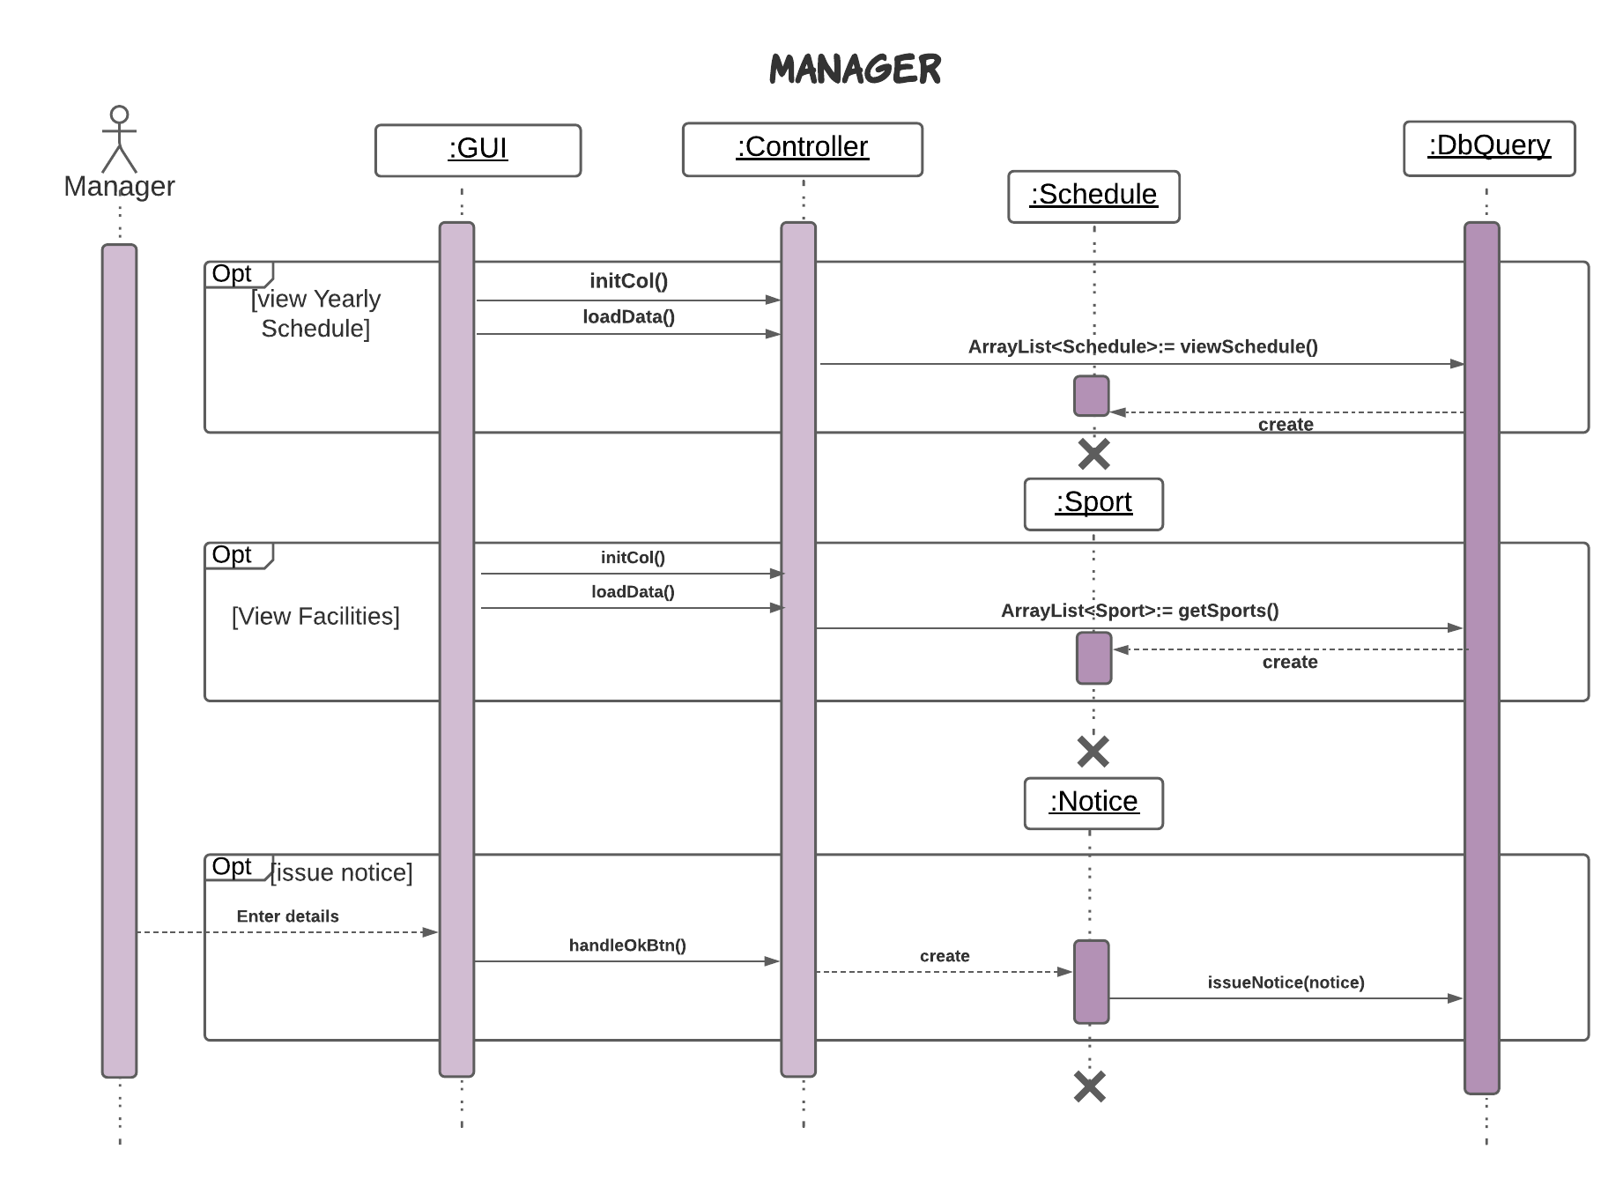

* + 1. **Finance**

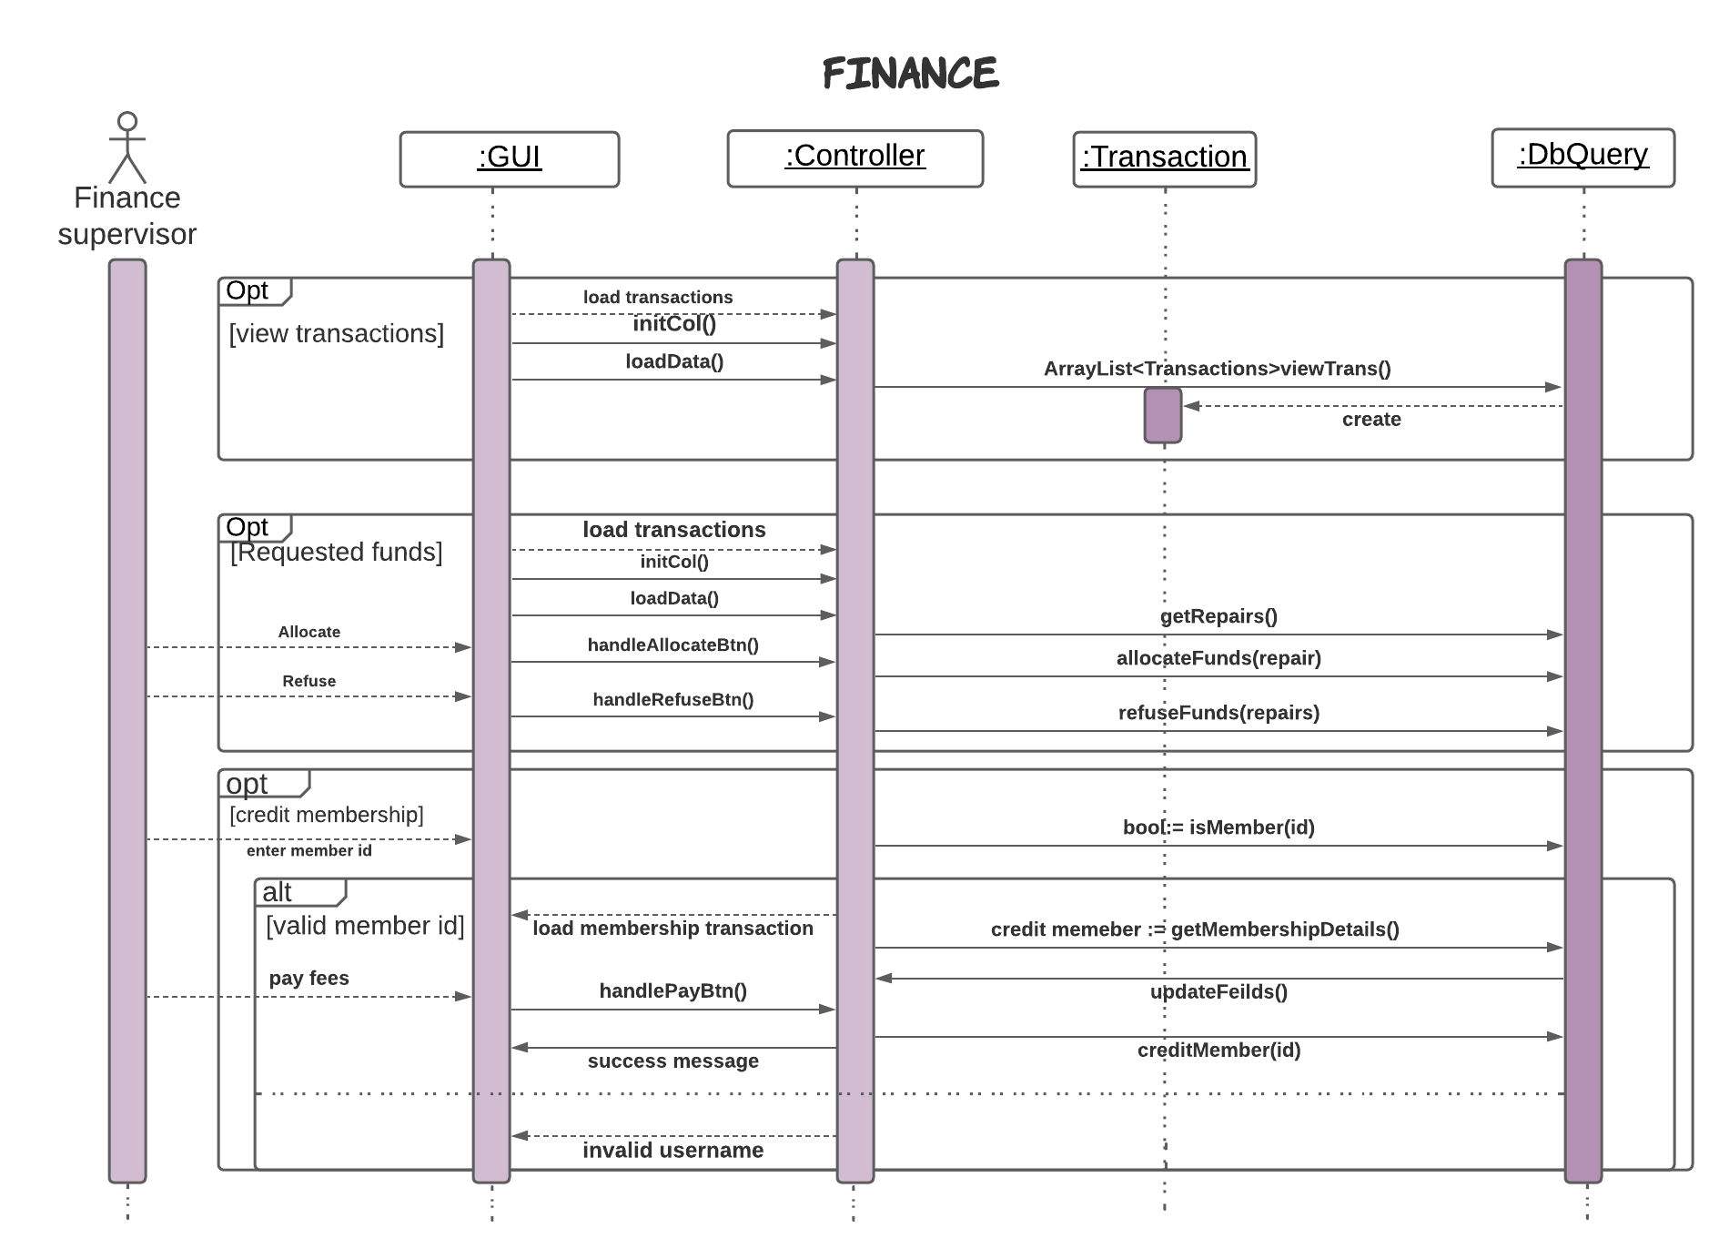

* + 1. **Coach**

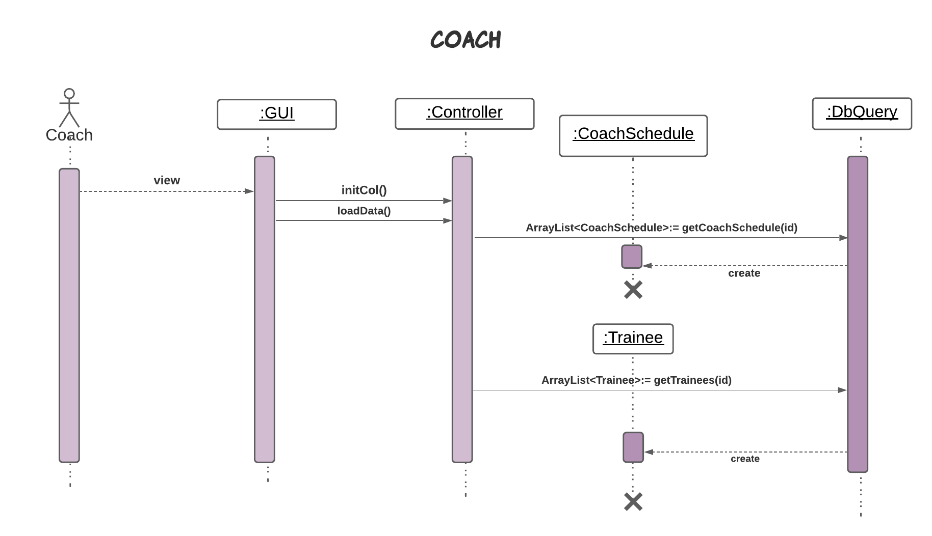

* + 1. **Inventory**

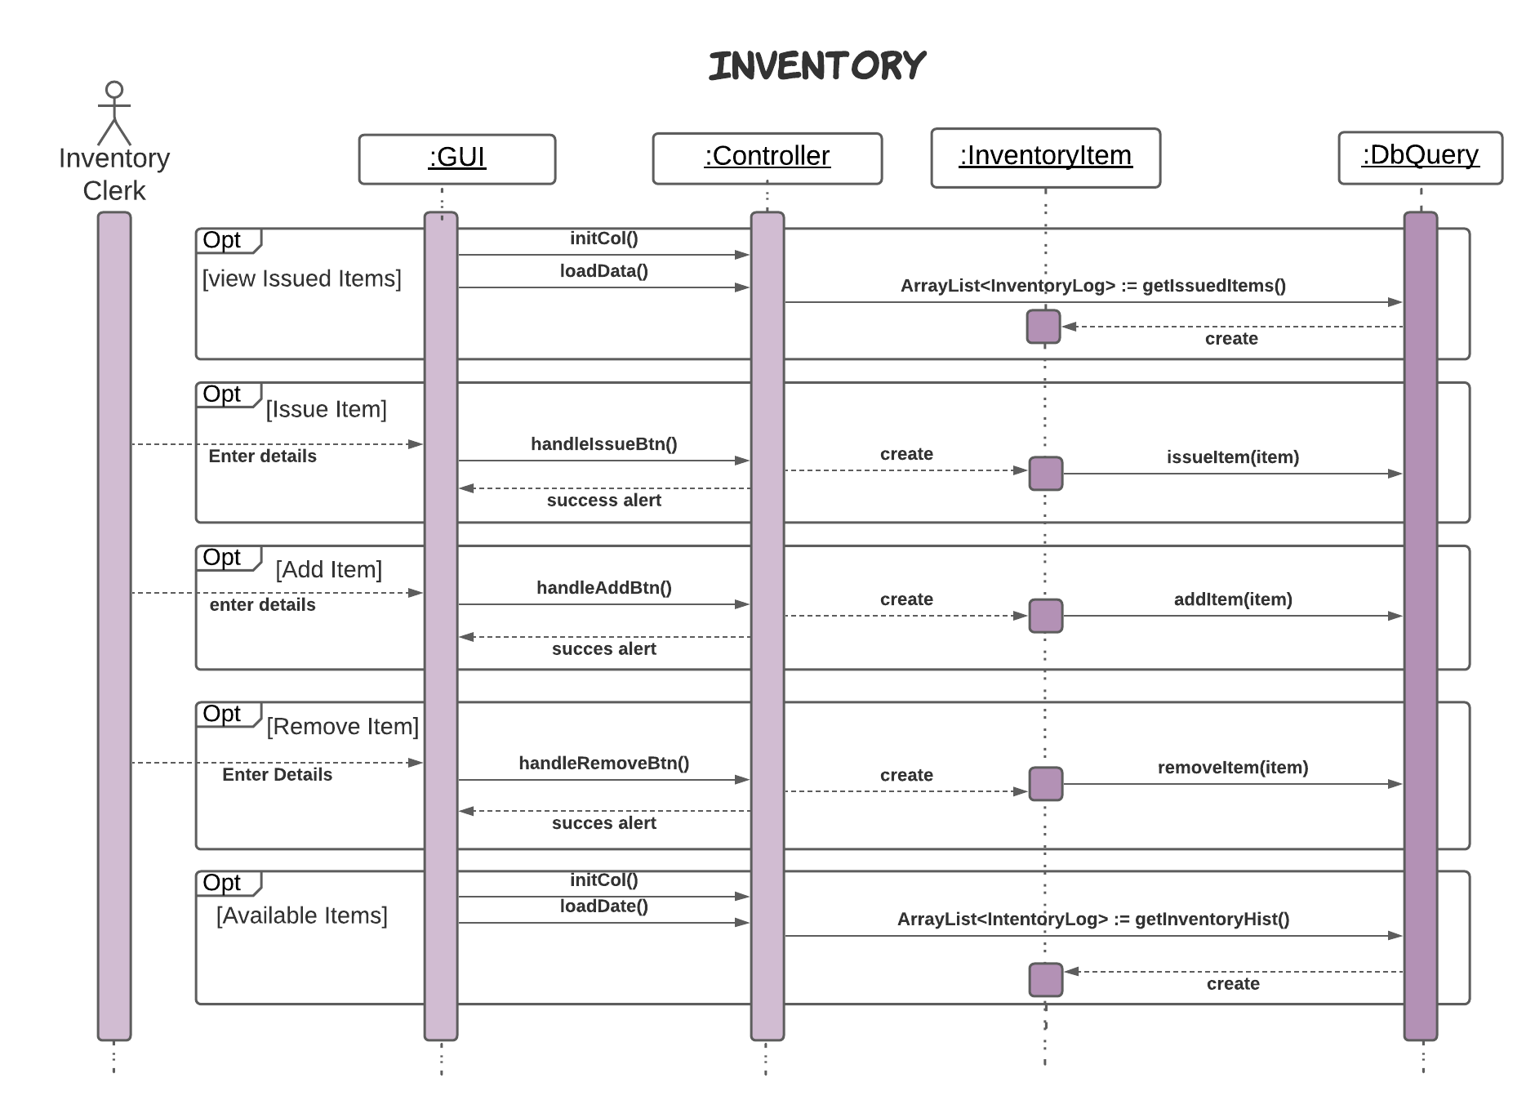

* + 1. **Maintenance**

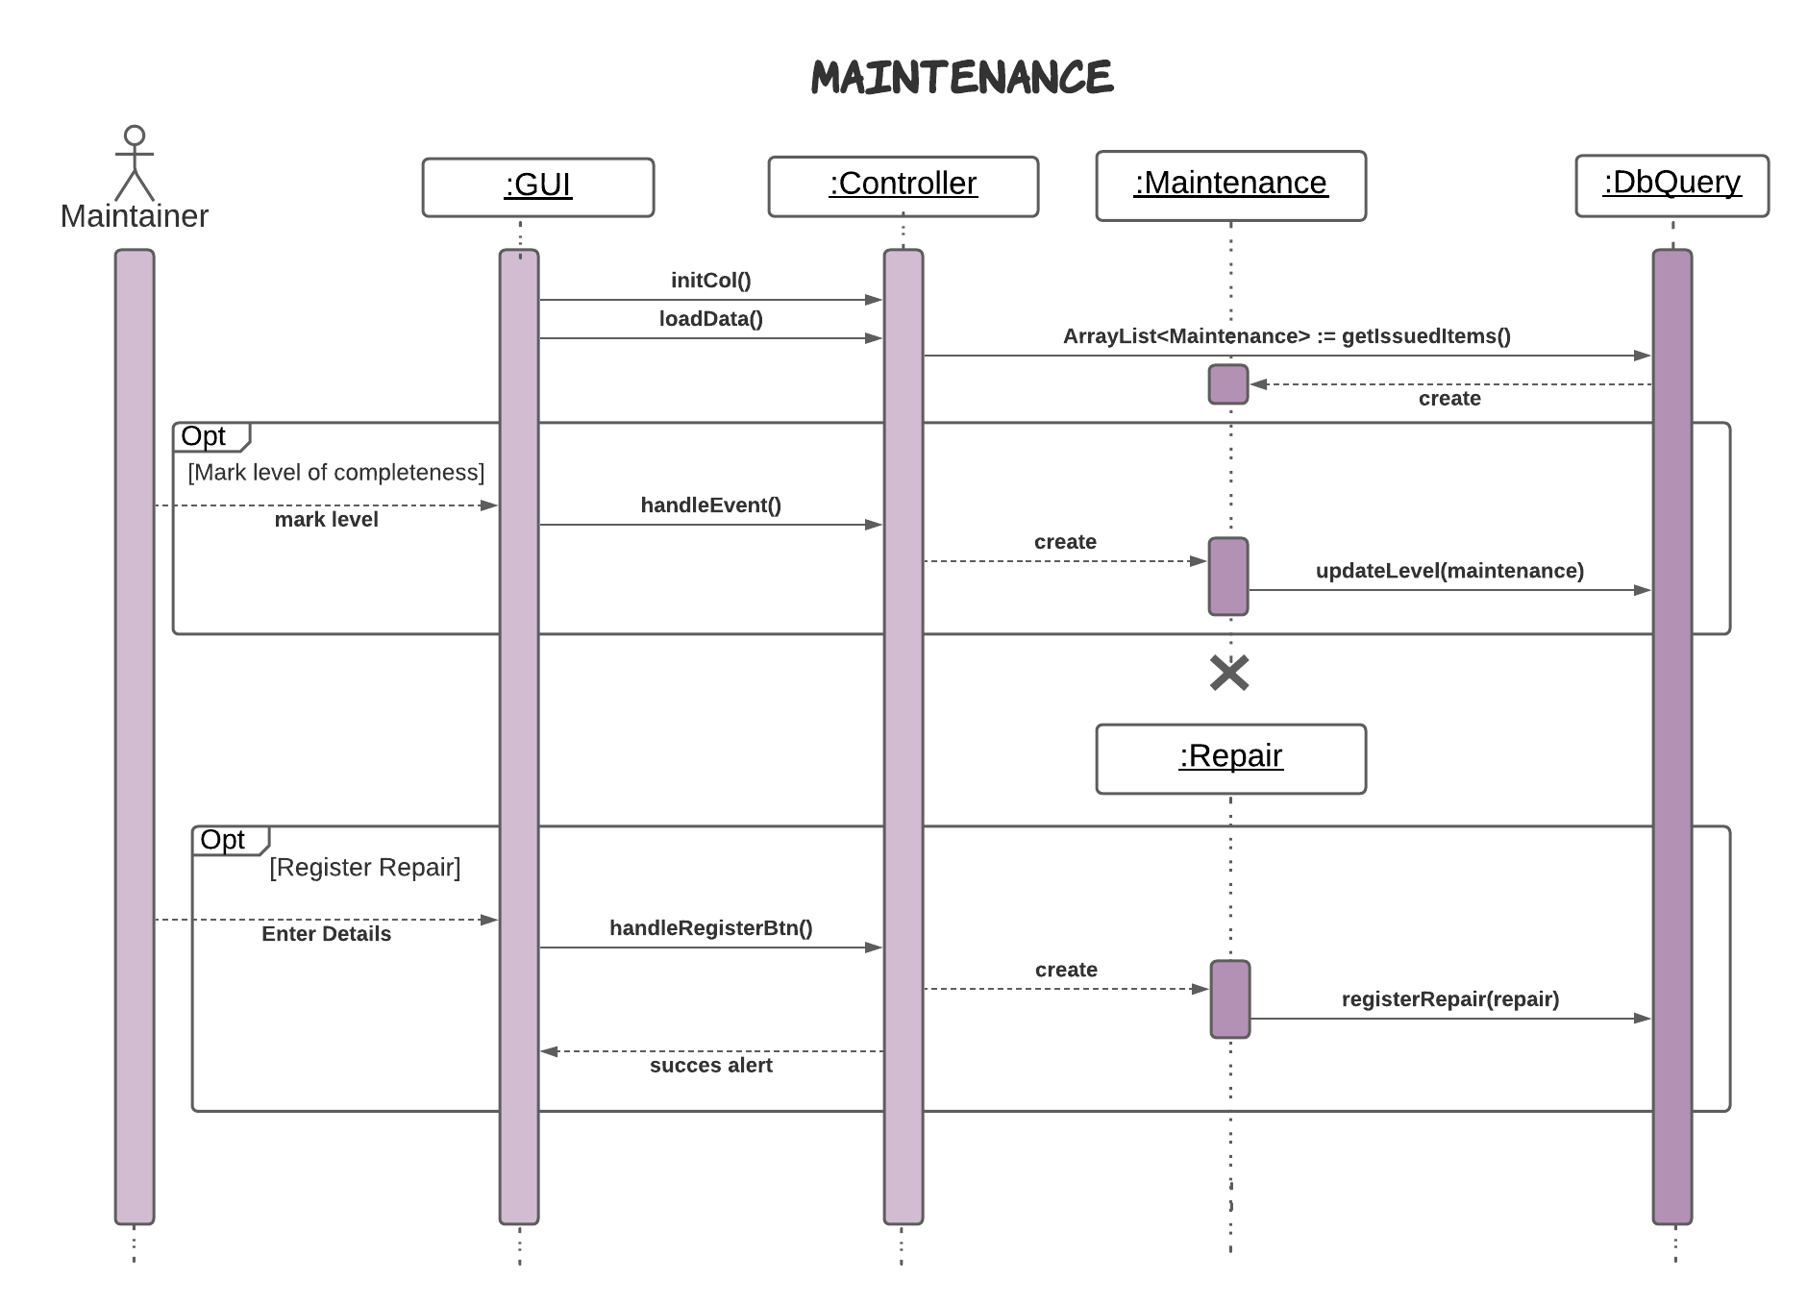

## Communication Diagrams

### Login

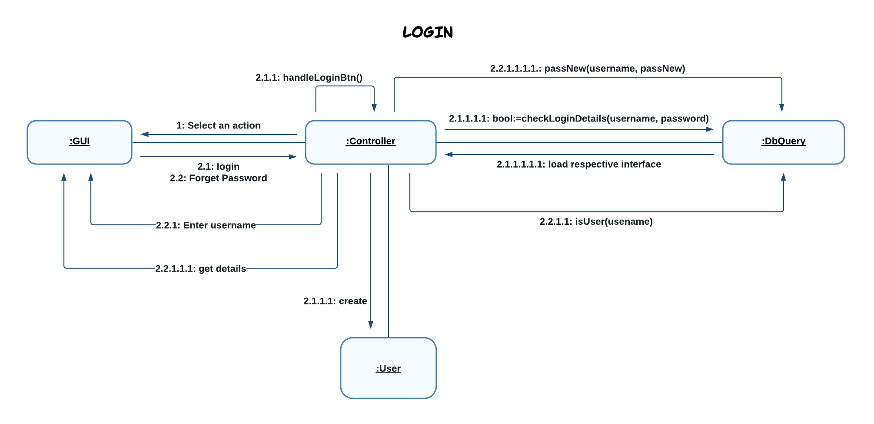

* + 1. **Registration**
       1. **Manage Members**

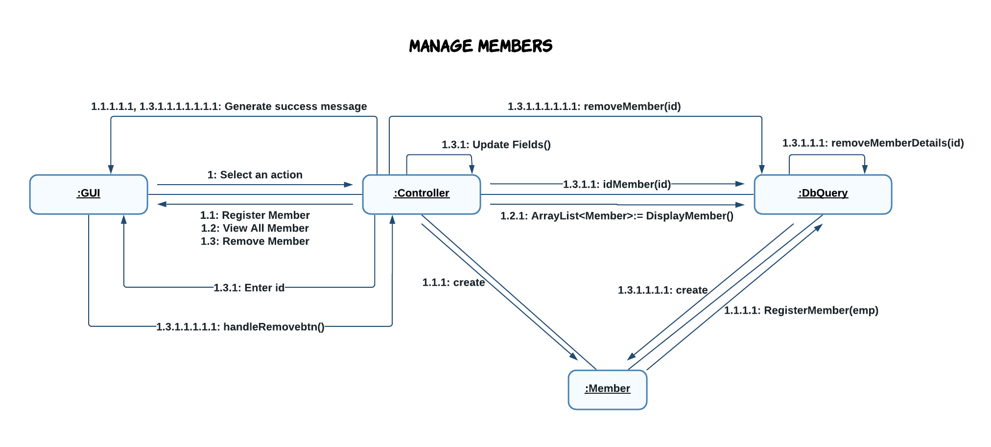

* + - 1. **Manage Employees**

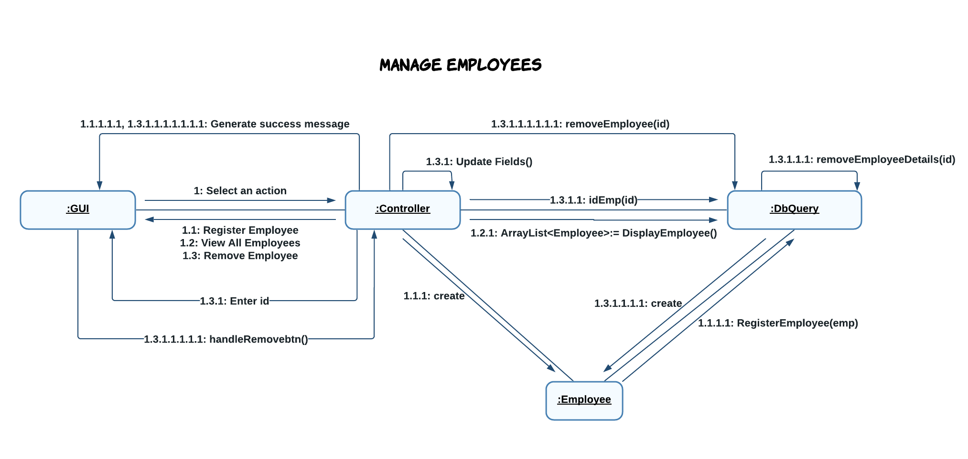

* + - 1. **Manage Teams**

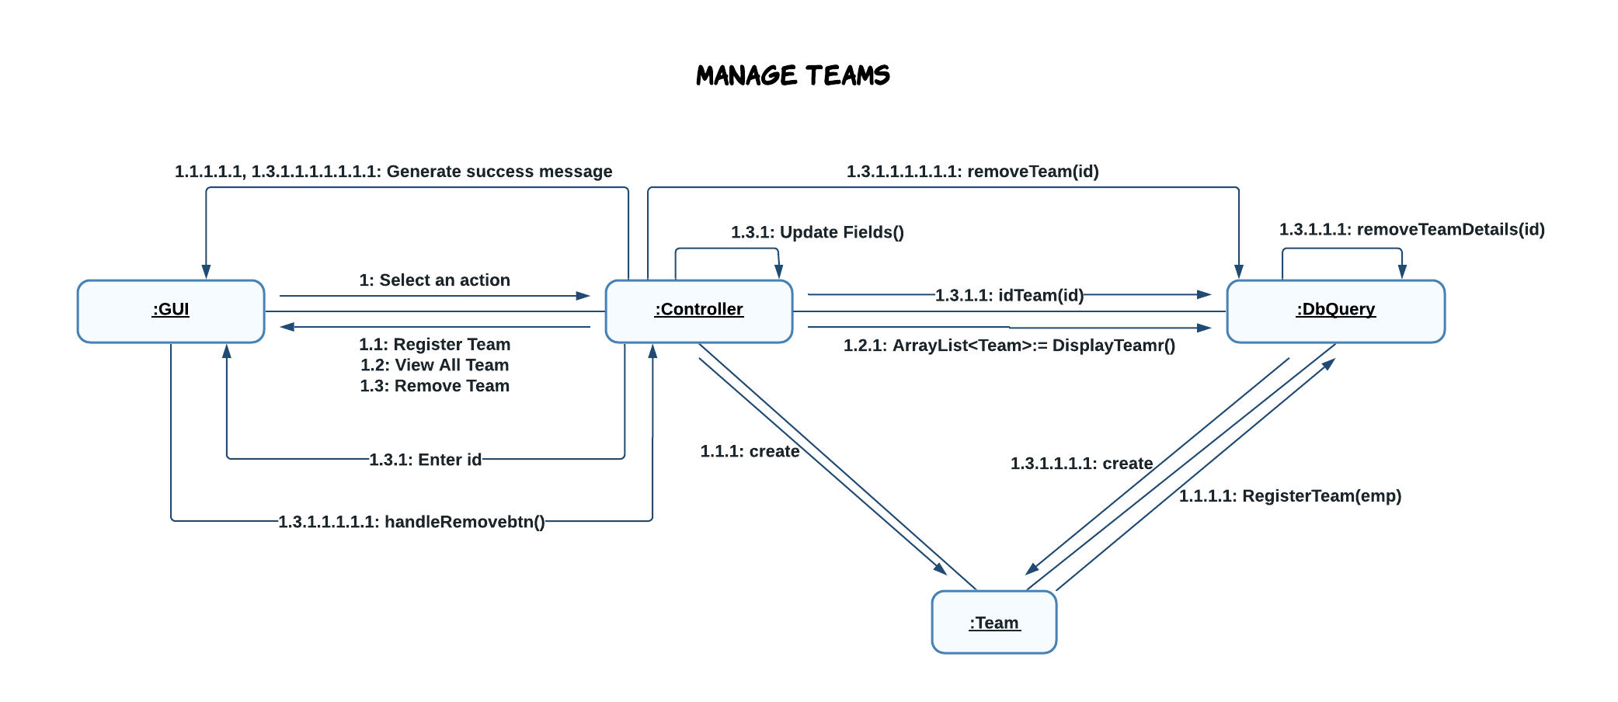

* + 1. **Manager**

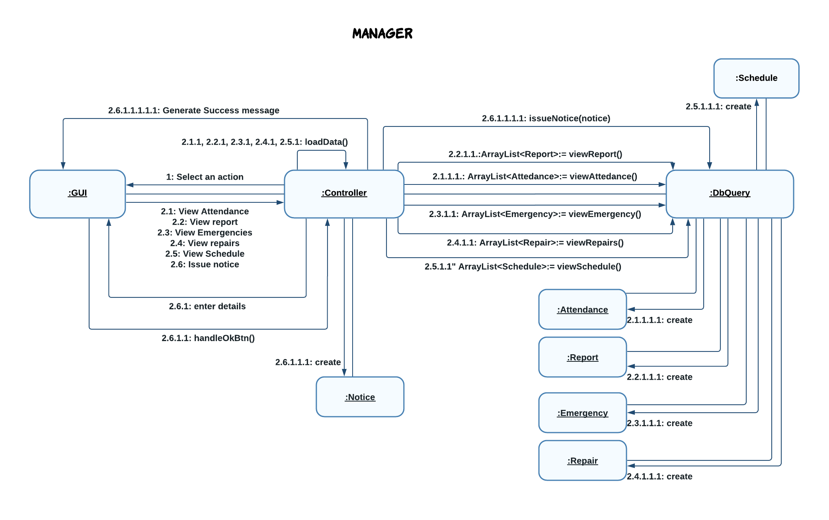

* + 1. **Finance**

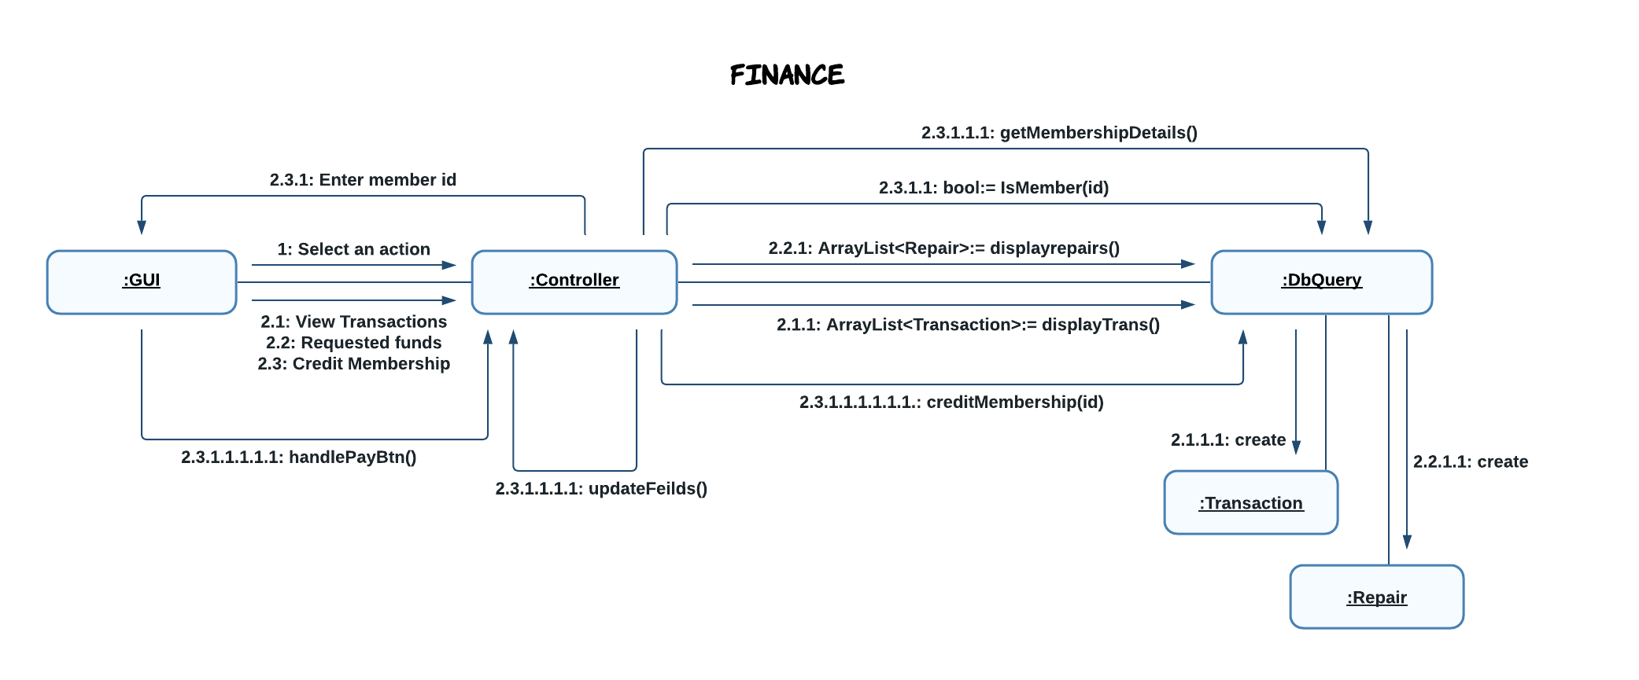

* + 1. **Coach**

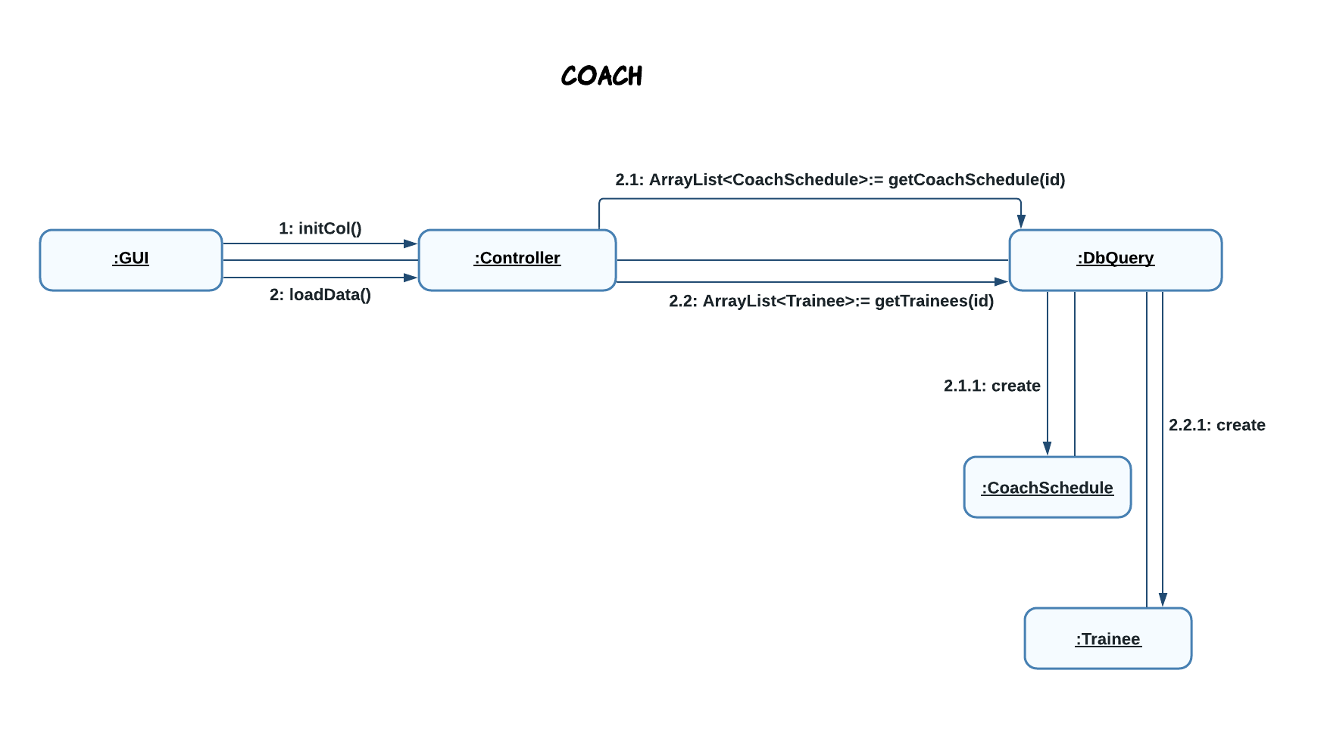

* + 1. **Inventory**

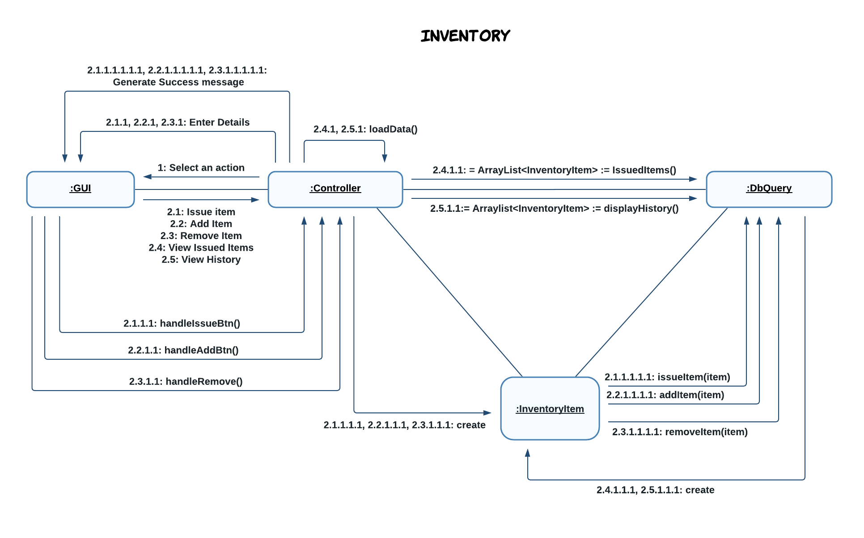

* + 1. **Maintenance**

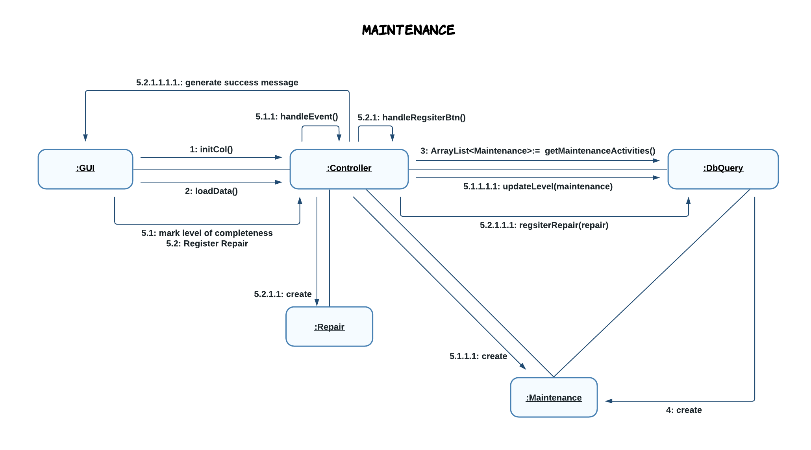

## Activity Diagrams

* + 1. **Login**

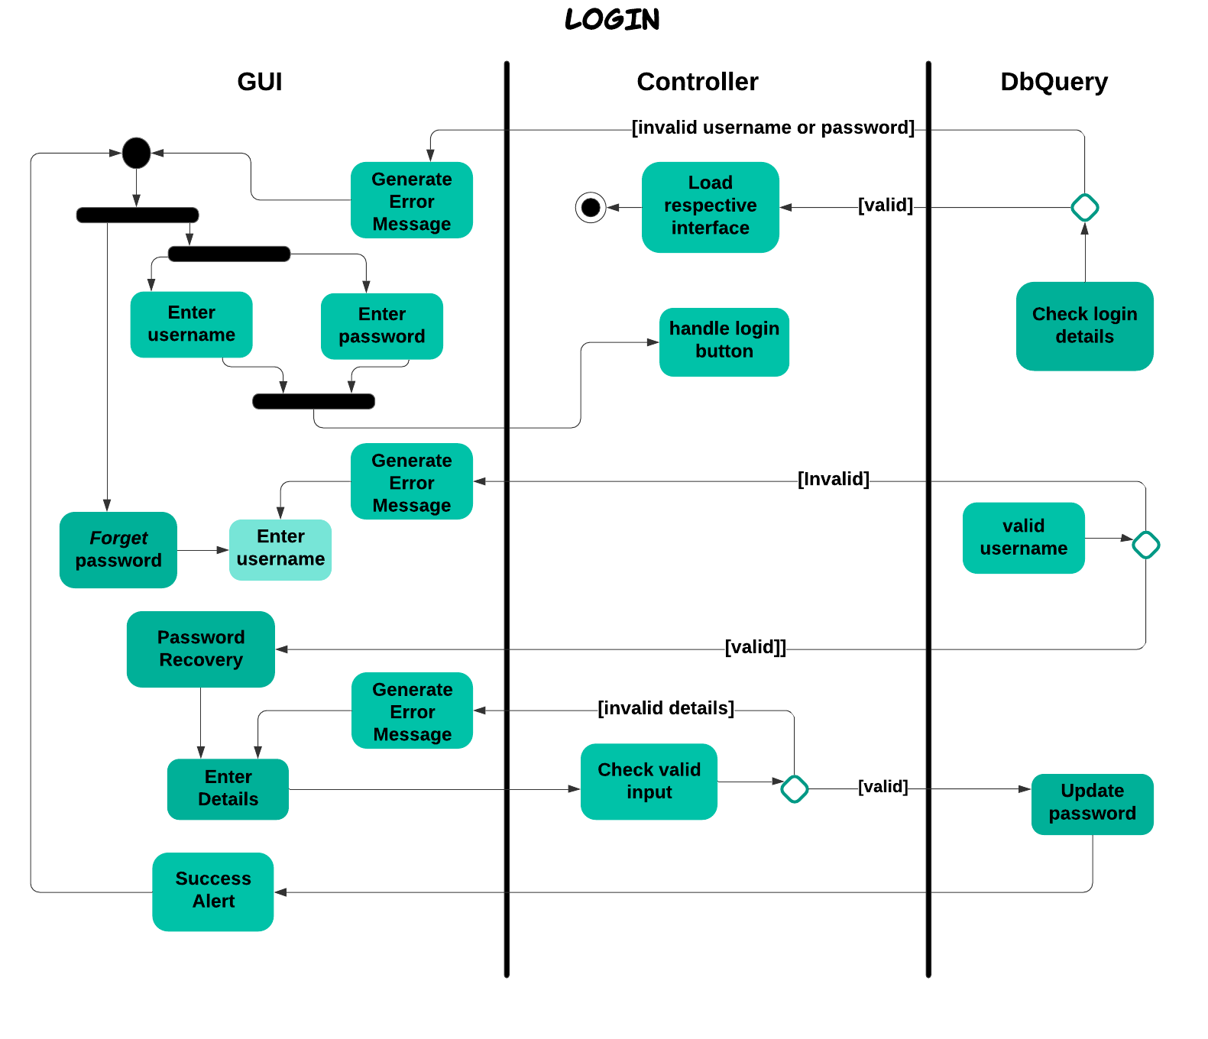

* + 1. **Registration**
       1. **Manage Members**

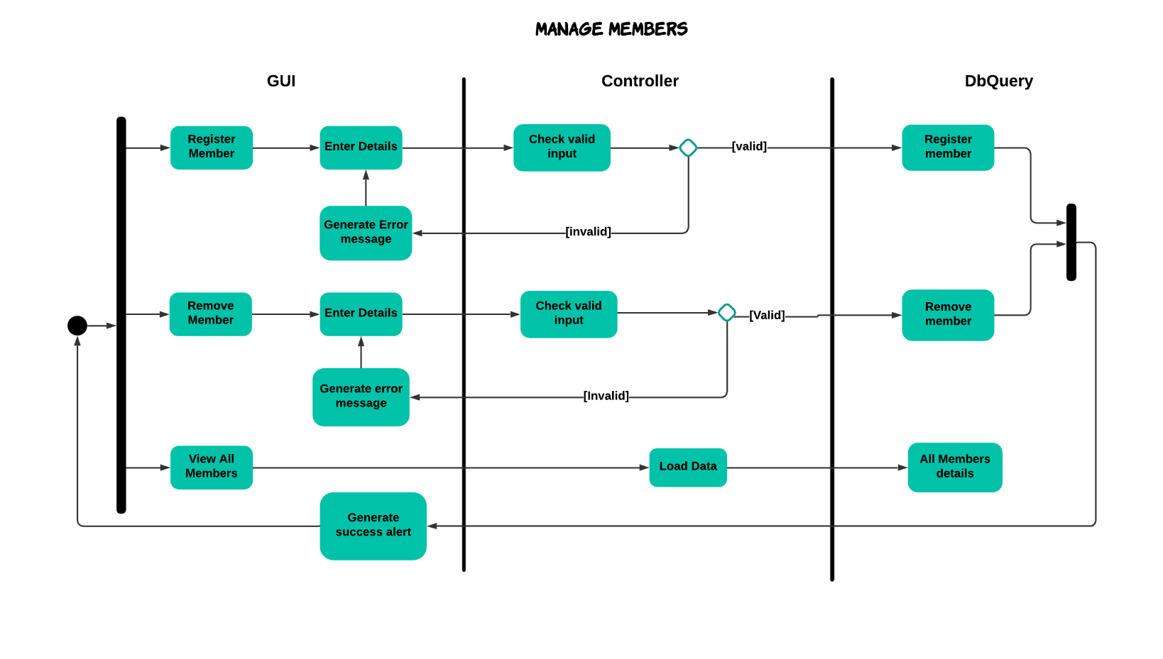

* + - 1. **Manage Employees**

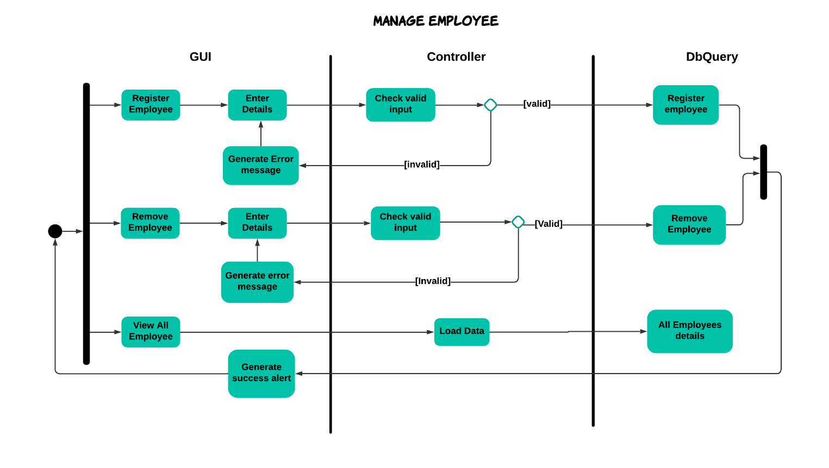

* + - 1. **Manage Teams**

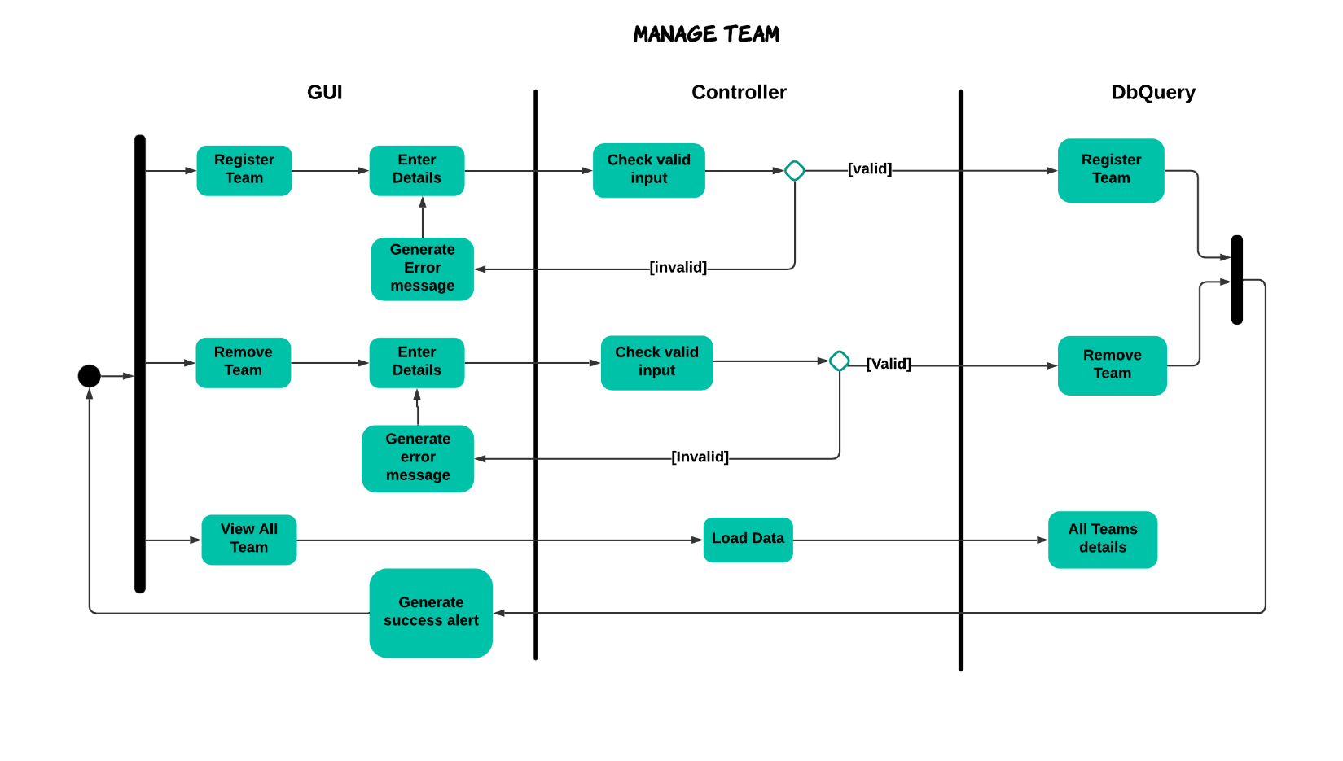

* + 1. **Manager**

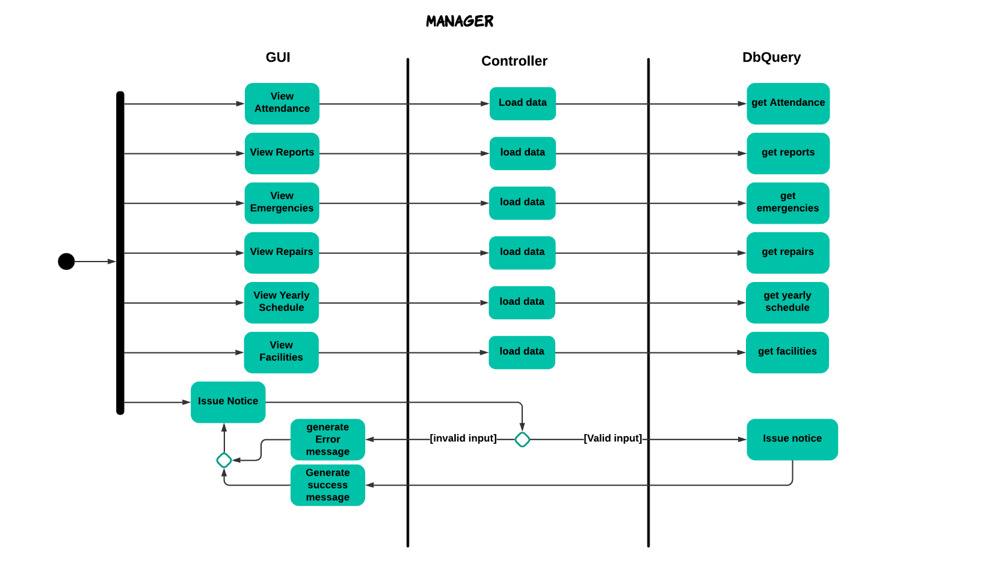

* + 1. **Finance**

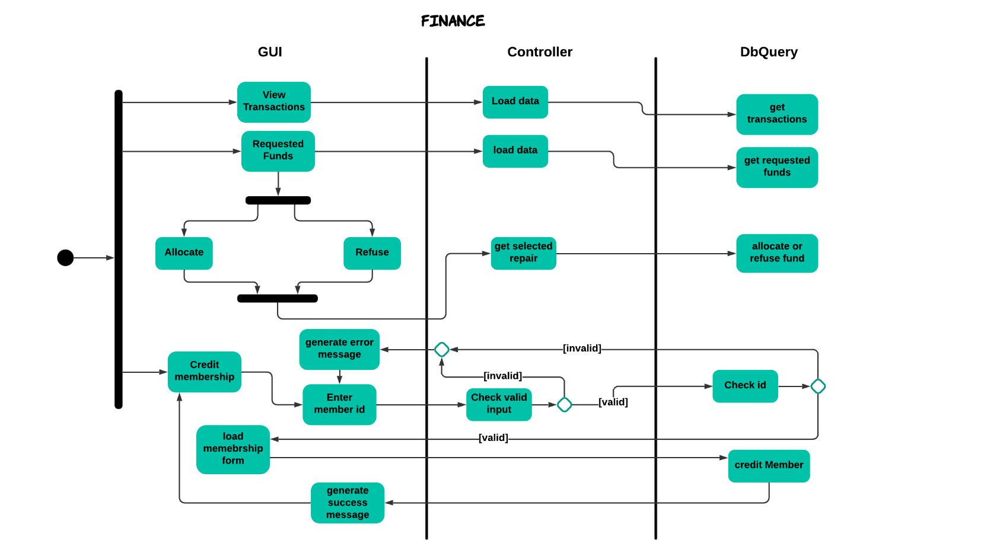

* + 1. **Coach**

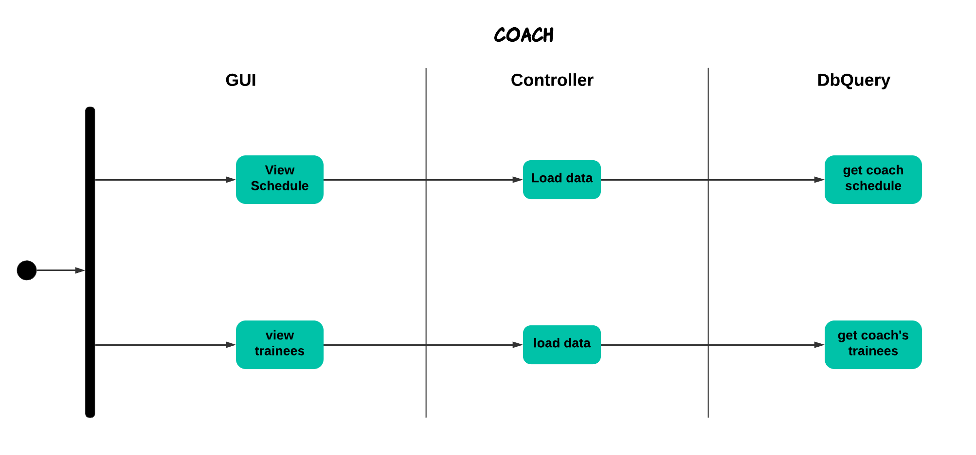

* + 1. **Inventory**

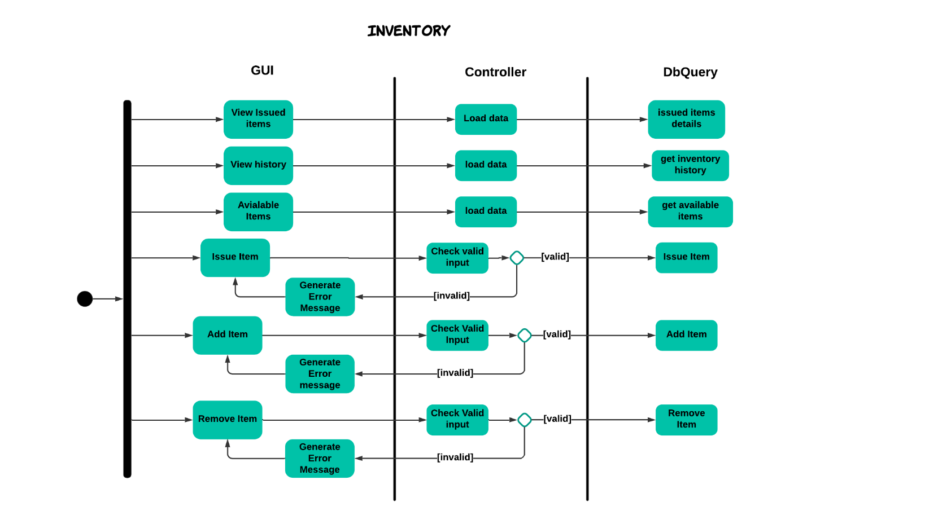

* + 1. **Maintenance**

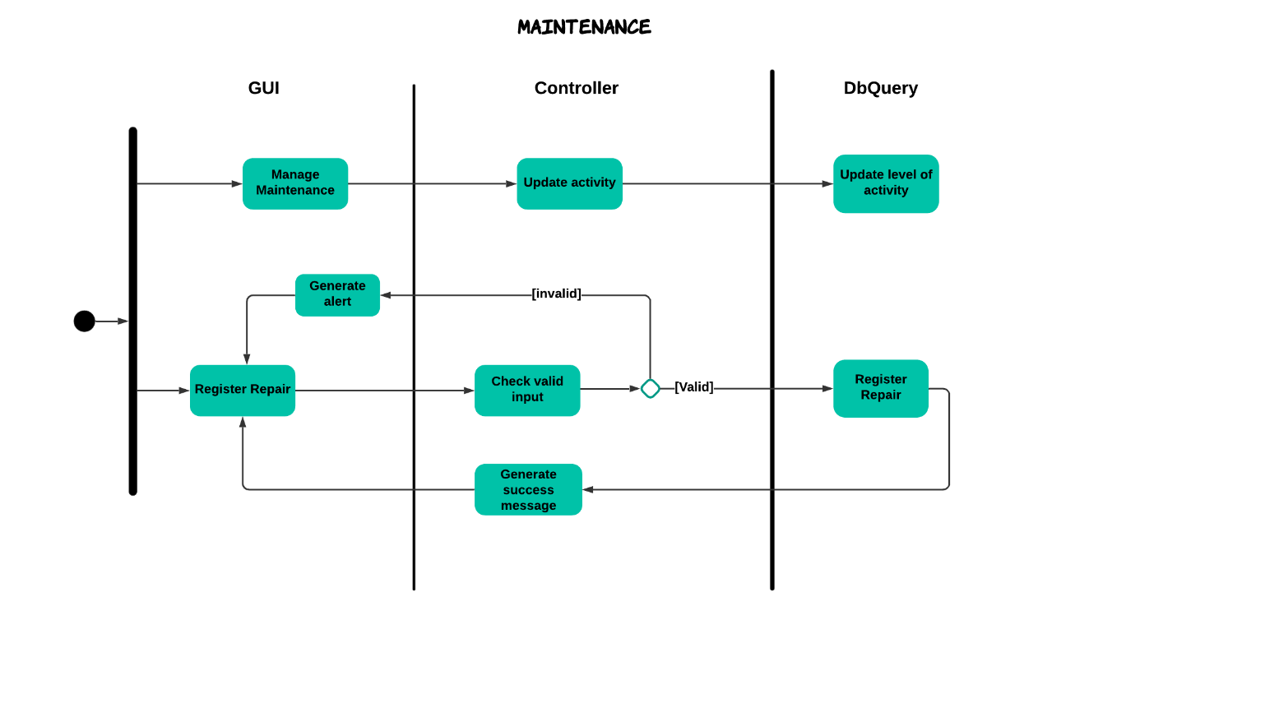

## State machine diagram

* + 1. **Registration**

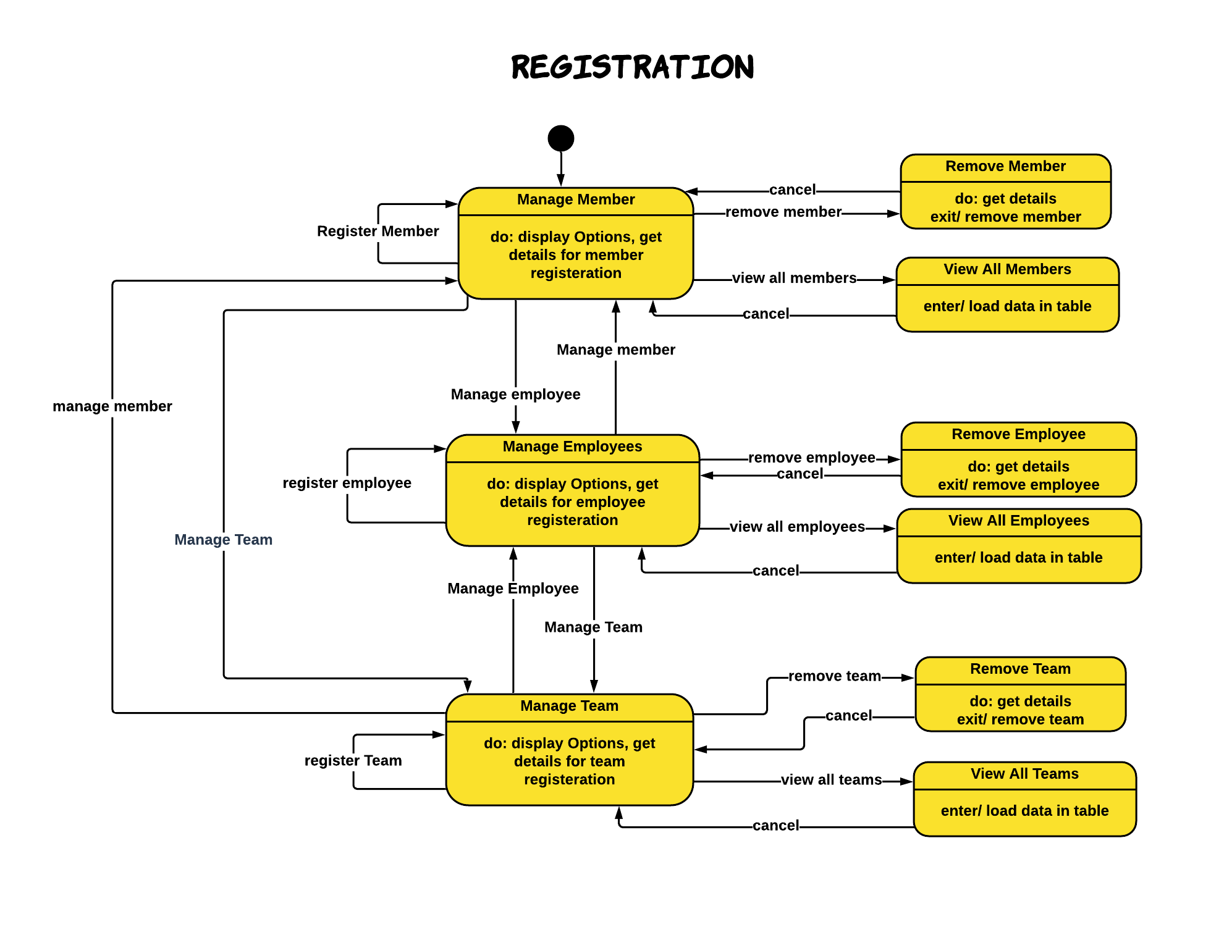

* + 1. **Maintenance**

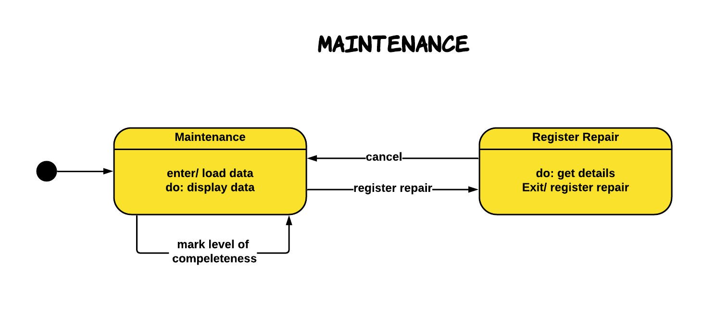

* + 1. **Manager**

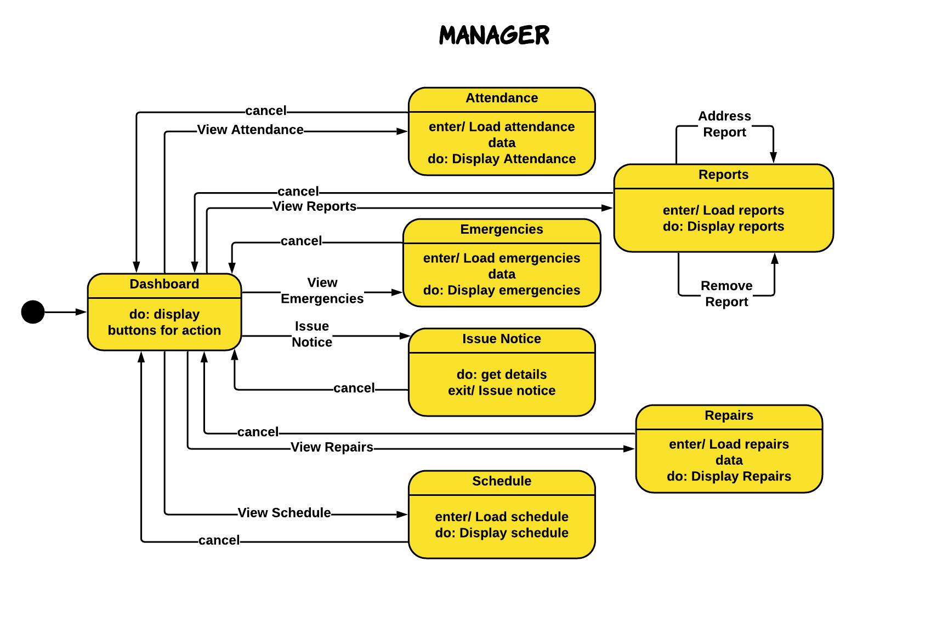

* + 1. **Coach**

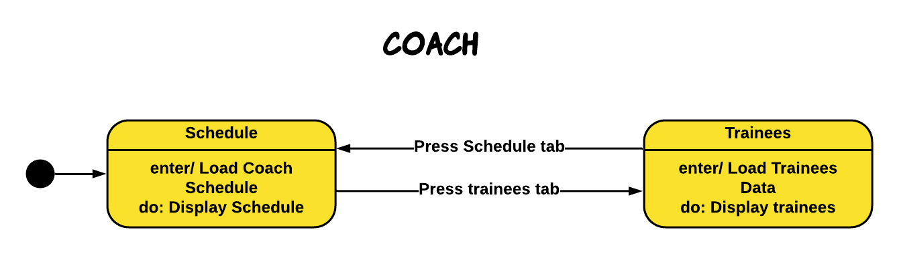

* + 1. **Inventory**

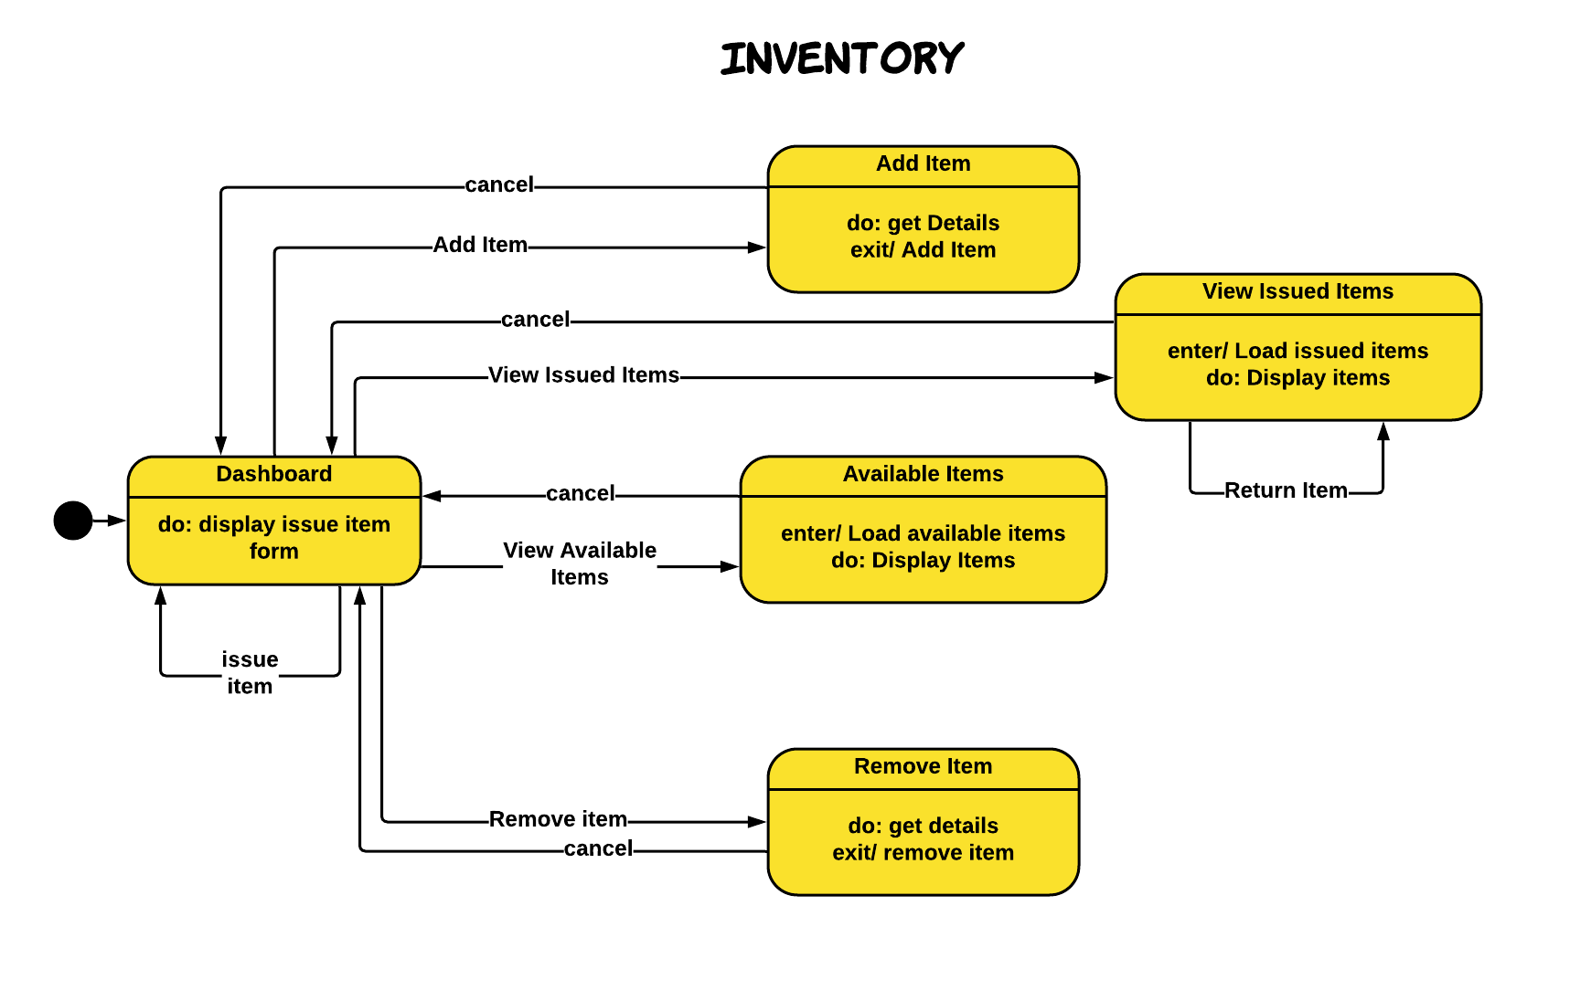

* + 1. **Finance**

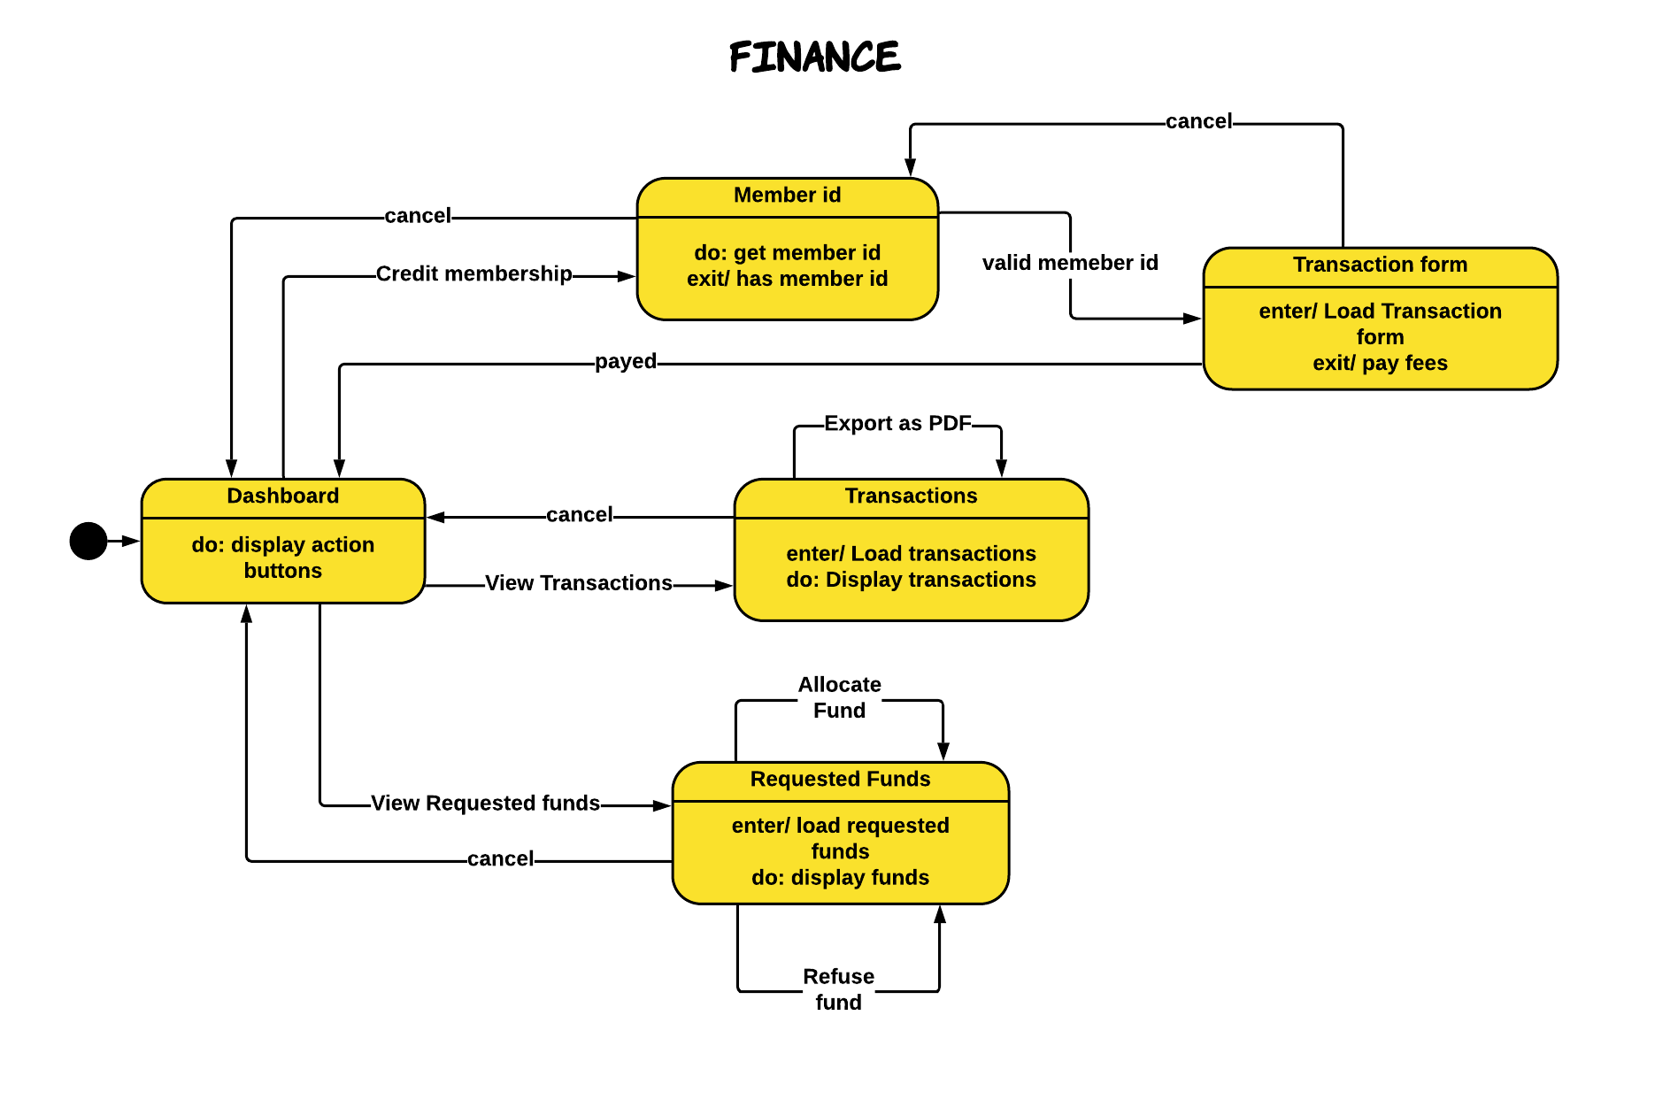

## Deployment Diagram

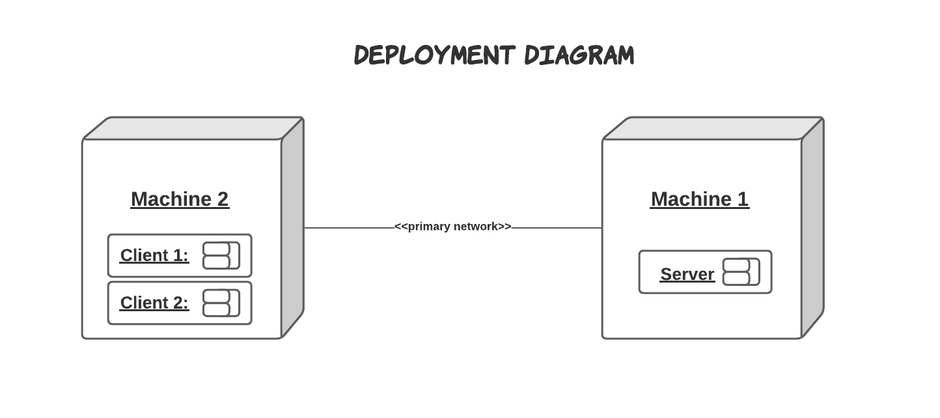

## Component Diagram

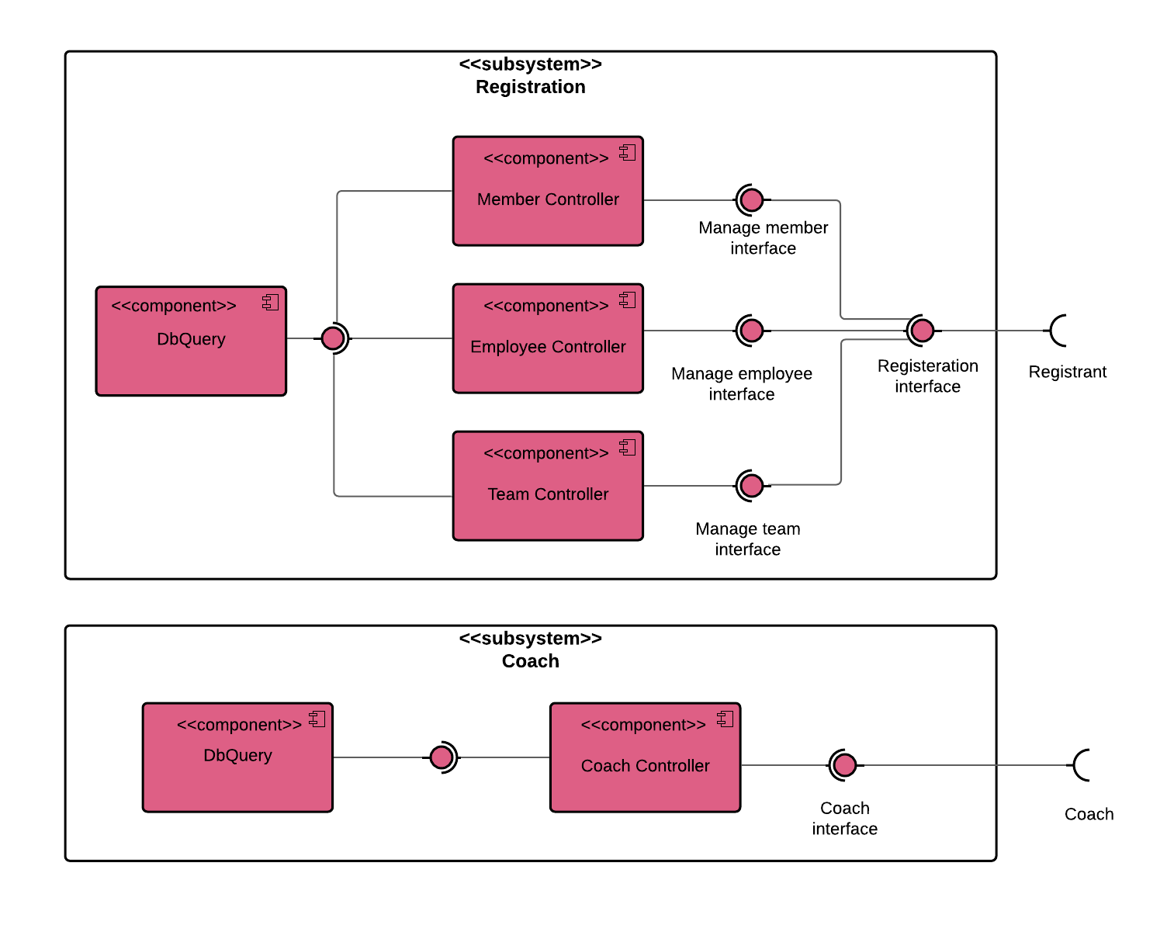

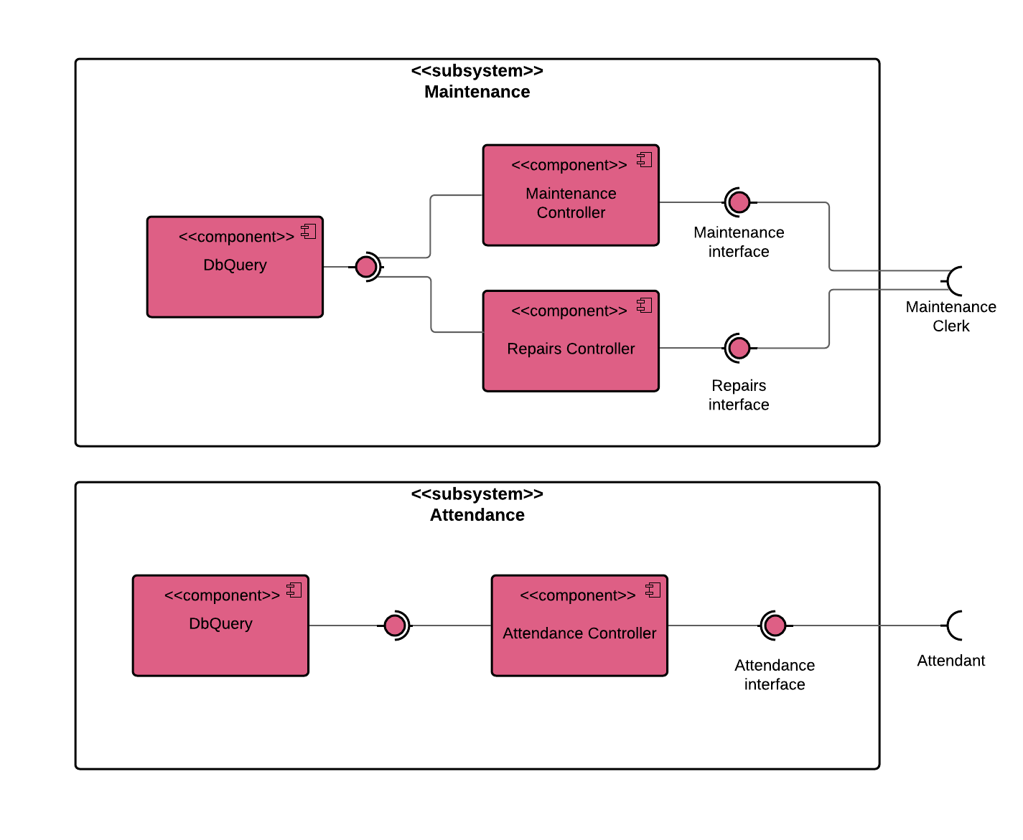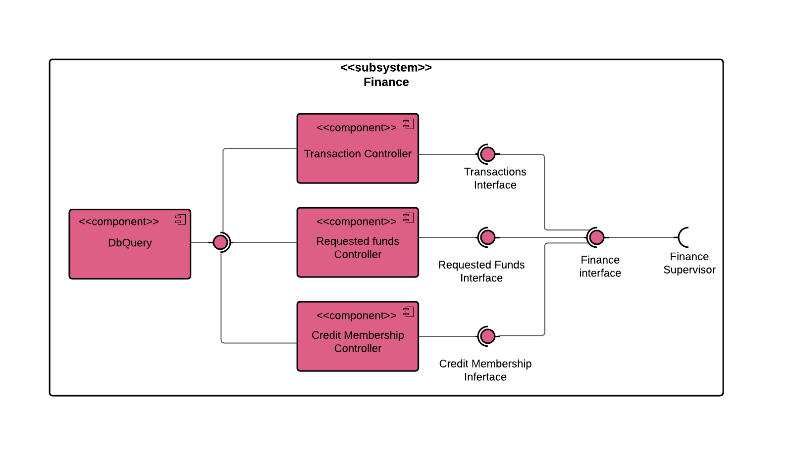

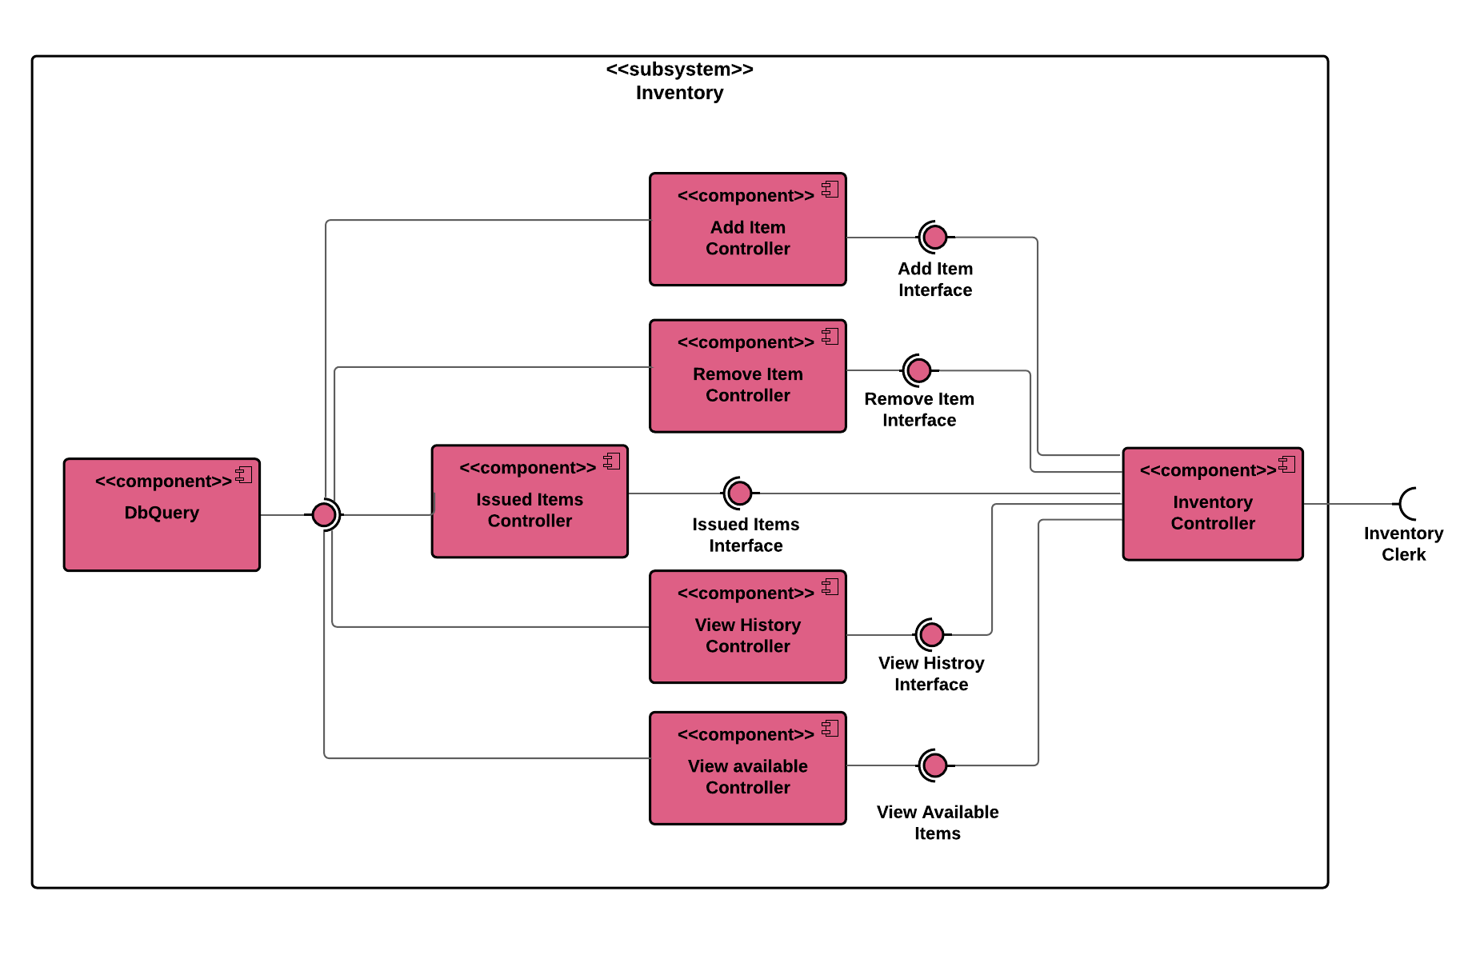

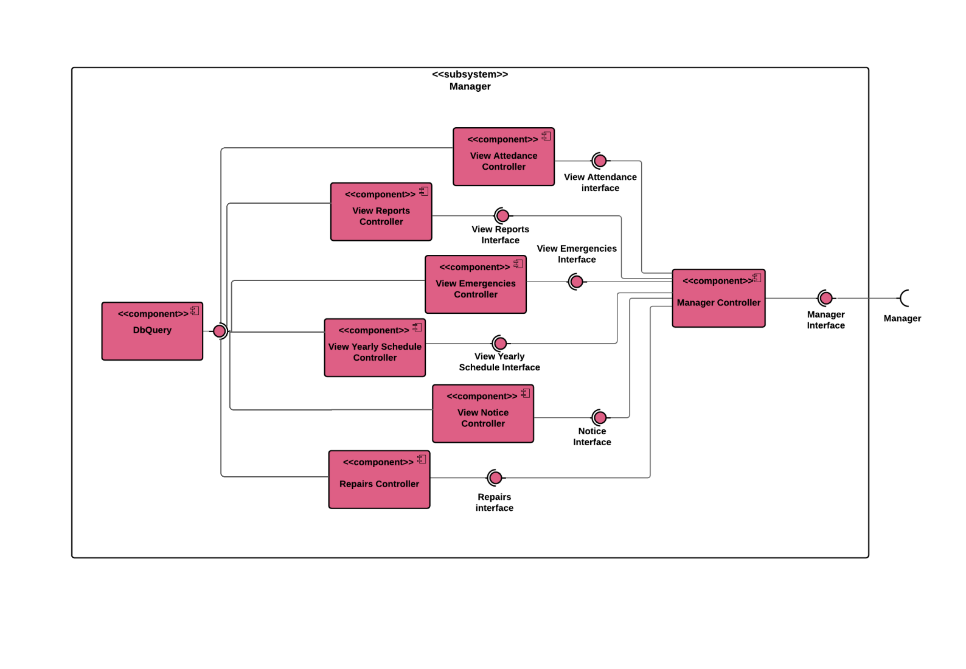

## Package Diagram

